# “‘SINCE NO EXPRESSIONS DO’:

# QUEER TOOLS FOR READING, EDITING, AND ARCHIVING LITERATURE”

by

# FILIPA DA GAMA CALADO

Admitted to the GC Faculty

Etc.

2023

© 2023

# FILIPA DA GAMA CALADO

All rights reserved

APPROVAL

# THE CITY UNIVERSITY OF NEW YORK

ABSTRACT

“‘Since No Expressions Do’: Queer Tools for Reading, Editing, and Archiving,”

by

Filipa da Gama Calado

This dissertation explores how digital methods and tools for studying text engage with queer literature. I critique digital methods and tools by posing computation, where textual data is cleaned and structured for electronic processing, against the complexity of queer subjecthood and affects expressed in textual style, form, and voice. While tools like quantitative text analysis, for example, transform (and necessarily reduce) qualitative elements of gender and sexuality into numerical data such as word frequencies or concordances, I argue that this reduction opens up possibilities for interpreting the formal qualities of queer literature which expresses queerness in narrative and figurative structures. Just as digital formats transform and manipulate text into data, so do literary forms figure queer identity and experience. Approaching queerness and computation as formal phenomena challenges scholars to defamiliarize their knowledge about technology and to rethink the “digital” as something at once tangible, slippery, and distinctly queer.

Besides offering new digital procedures for studying textual material, my work also poses a crucial critique of Queer Studies and the way it theorizes the relationship between sex, gender, sexuality, and race. The order of chapters in my dissertation poses a trajectory for the field of Queer Studies that increasingly grapples with the role of race in queer identity. This critique of Queer Studies and its implicit whiteness strategically poses queerness as something that as José Esteban Muñoz argues, is “not yet here,” but perpetually on the horizon (1). In this project, queerness remains as a target beyond reach, as a fount for future subversions, exemplified with the term “queer” itself, which Butler says “never fully owned, but always and only redeployed, twisted, queered from a prior usage and in the direction of urgent and expanding political purposes” (173).

# ACKNOWLEDGMENTS

First, I want to thank my advisor, Matt Gold, whose faith in my work has been constant since my first semester in his class, back in Fall 2017. He is one of the few academics, particularly within English departments, who has always encouraged (and never expressed doubt) about the way I have been thinking through language and digitality.

I want to thank my readers, Amber J. Musser and Wayne Koestenbaum, both of whose courses helped alter the trajectory and focus of my research interests.

A massive thank you to my “digital family” at the Graduate Center, including Rafael Davis Portela, Patrick Smyth, Stefano Morello, Param Ajmera, Di Yoong, Olivia Ildefonso, Javier Otero Peña, and special thanks to Lisa M. Rhody, who taught me more than she will ever know.

I want to thank my friends at the English department, especially Jacob Aplaca, Margot Kotler, and Chad Frisbie. I also want to thank my friends outside the academy, who never quite understood what I was doing during the PhD but always cheered me on: Patrick Rizzuto, Alexis Fearon, and Margery O’Connor.

Thanks to my students at Hunter College, City College, New York University, and the New School, who taught me about *Orlando*, *Dawn*, and Gloria Anzaldúa.

Finally, my family, who definitely never understood my work, though they try harder than my friends: my parents Miguel Calado and Maria Adelaide Calado; my siblings Mariana and André; and newer additions: Drew and baby James.

Also, to my extended Portuguese family who, like all good Portuguese, are spread all over the world, though if we are lucky, we’ll see each other soon in Algarve.

Obrigada.

# CONTENTS

INTRODUCTION…………………………………………………………………………………....1

CHAPTER 1: “‘A Melon, An Emerald, a Fox in the Snow’: Quantifying Gender

in Virginia Woolf’s *Orlando: A Biography*”……………..…………………………………………19

# CHAPTER 2: “‘Where there is Spectacular Passion, they would Suggest Something

# Vile’: Encoding Queer Erasure in Oscar Wilde’s The Picture of Dorian Gray”…………………...49

# CHAPTER 3:

# 87

# CONCLUSION:

# ##

INTRODUCTION

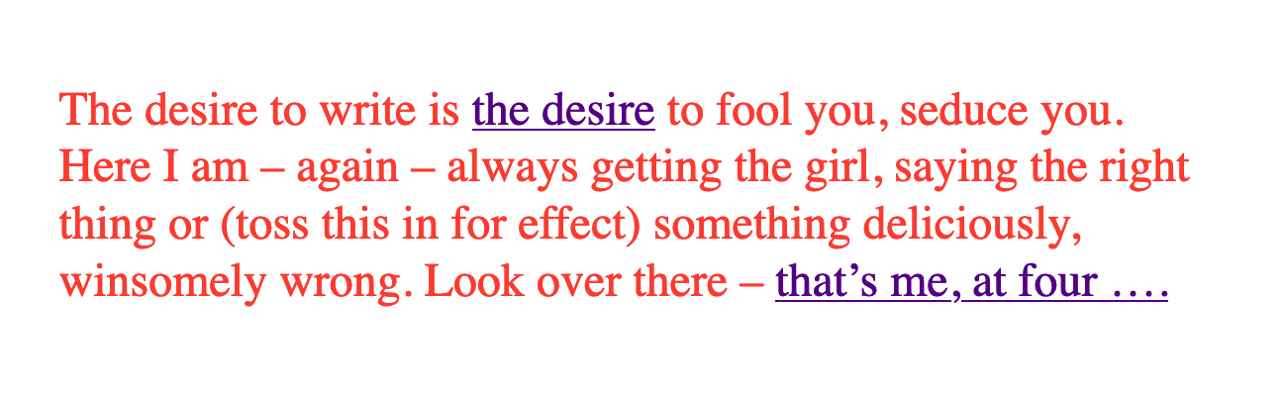

Figure 1: Screenshot from *These Waves of Girls*, “desire_to_write.htm.”

Caitlin Fisher's electronic work, These Waves of Girls, tempts the reader through its pages with links to seductive phrases like "the desire" or "that's me, at four…" ("desire_to_write.htm"). Though they are associative in nature, supporting the work's de-centralized formal structure, the links also defer narrative coherence within the story, a sexual coming of age of a young lesbian woman named Tracey. Clicking through a few episodes, the text reveals itself to be, like much of the "hypertext fiction" of the time, disorienting. The links offer a profusion of narrative paths that disrupt the relationship between cause and effect, halting the narrative progression in what James Pope describes as "a baffling range of choices for movement which actually led to a stifling of movement altogether" (11).



Figure 2: GIF of *These Waves of Girls*’s opening menu and one possible reading path.

In addition to dogging this perpetual deferral of narrative coherence, the reader also follows the narrator's elusive promise of sexual discovery, of which she only ever gets part. One highly eroticized scene, for example, uses linking to cast the object of Tracey's desire into doubt. Here, the 15-year-old Tracey performs a gymnastics "beam routine" for an older man:

‘I don’t want to have sex,’ I say. ‘Not with you.’

But then, not wanting to disappoint, ‘I could do my beam routine.’

I take off my clothes and, fifteen, mount the line of the carpet to perform my entire junior beam routine, handstand press, two backhandsprings included. He jerks off. Dismount.

I hurry into my clothes and head home to Vivian (_who loves me, but not as much as I love her_). For years I worry that the shoe salesman was really disappointed, stuck with a fifteen year old virgin gymnast rather than a real bad girl. "Beamroutine8.htm"

The beam routine performance enacts a tension between touch and desire that drives not only the narrative story but also the reader as she clicks her way through the links. In compensating for the sex act, the visual performance of beam routine suggests a desire that is inaccessible to touch in two ways. First, on the level of narrative form, the object of desire is cast into doubt by the phrase, "I don't want to have sex, not with you," instead implying her friend Vivian, to whom Tracey declares her love earlier in the episode ("Our third daiquiris arrive and, my hand hot on her waist, "I tell her I love her" (“beamroutine5.htm”)), as the object of desire. However, on the level of format, desire's referent is destabilized by the text's associative structure. The link to this same sentence, "I don't want to have sex," leads to a page about another love object, Jennie Winchester:

I’m in bed with Jennie Winchester and I realize she wants me to undo her pants. She needs to be home by 11:00 and needs to leave my place by 10:45. I’m kissing her but opening my eyes at intervals to catch the clock. At exactly 10:43 I unbutton her Levis and shove my hand inside, barely undoing the zipper. “I’m in bed…”

The association between Jennie and Vivian, both of whom are depicted as highly desirable partners throughout the work, and the assertion "I don't want to have sex," throws Tracey's desire into doubt. The links here create a disorienting effect where the reader constantly loses context even as she familiarizes herself with the events of the story. The difficulty in "grasping" the story on a physical level, on the level of format, in literally clicking through the various episodes, reinforces desire as a moving target on the level of narrative form, in the seemingly arbitrary relationship between cause and effect throughout the story. The links thus facilitate a frustrated relationship to touch, where the reader clicks through a story she will never fully grasp, to read a story about a desire that is never fully defined. This confusion in navigating through Waves, in re-interpreting fragments that had been previously integrated, characterizes desire, and queer desire in particular, as something elusive.

I open with this work because it illustrates a foundational assumption for this dissertation–that digital media abstracts complex elements of queer identity, desire, and experience in text into formal possibilities for analysis. In Waves, for example, where desire is distributed across a network structure, the network becomes a formal device for exploring queer desire. This text puts into practice post-structuralist principles about the destabilization and de-centering of literary narrative in a continually branching network that shifts and scrambles the reader's sense of direction.[1] Despite this apparent disorder, however, movement across the text is highly constrained by standards that rule all network connections, what Alexander Galloway refers to as network "protocol." Protocol operates mostly out of view, taking the form of technical standards like HTML (HyperText Markup Language) that control the connection between pages in the story. The tension between this controlling structure and free movement within it recalls a condition of the network in which, according to Galloway, "protocol is synonymous with possibility" (168). The same rules that confine and determine movement can also be used to subvert expected behavior in the network, to seek out what hackers would call an exploit.

This project examines digital media for its constraints, particularly the ways it abstracts textual expressions of sex, sexuality, and gender into digital forms. Then, I explore how these constraints might engage theories and concepts from the field of Queer Studies. The network format as a controlling structure, for example, shares in the same principles that also influence the inception of Queer Studies with Judith Butler's Gender Trouble: Feminism and the Subversion of Identity in 1990. Butler's work establishes a denaturalization of sex, gender, and sexuality, famously exposing these categories as social constructions that precede and determine subjectivity rather than express it.[2] Her work lays the groundwork for Queer Studies' fixation with seeking out exploits that make resistance possible within the matrix of power. Bringing this fixation to Waves, I would explore how network dynamics engage categories and norms that define and delineate sexuality in this text. How might the subject, who comes into intelligibility through the matrix of discourse, relate to protocol as a controlling structure?

## Queer DH

This work is situated in an emerging field at the intersection of Digital Humanities (DH) and Queer Studies called Queer DH. While much of DH scholarship is driven by what Stephen Ramsay describes as "the heightened objectivity made possible by the machine," that is, social science methodologies that seek to test hypotheses and verify results, Queer DH emphasizes instead how digital tools and methods might productively complicate the stability and legibility of knowledge (x). In doing so, Queer DH projects generally take one of two approaches: the first imagines alternative digital tools that reflect the complexity and nuances of real-world objects and phenomena, while the second approach deconstructs and critiques existing tools, maintaining that queerness is inherent to computational logic.

The first approach often consists of speculative or critical making projects that do not work in a functional sense. Rather, these projects problematize the constructed nature of technical objects. For example, Zach Blas and micha cárdenas’s computer program, transCoder, contains programming functions inspired by Queer Theory, such as the "destabilizationLoop," which "breaks apart any process that acts as a continuously iterating power," and "nonteleo()" which "strips any program of a goal-oriented result" ("libraries.txt"). According to the authors, this pseudo-code project explores how "cultural layer of queerness… acts upon and mutates mutually with the computer layer of algorithms, binary logic, data structures, code, software, and digitization" ("about.txt"). Another example of this speculative strand of Queer DH is "Queer OS," a project that posits a theoretical operating system Kara Keeling's call for an operating system "take[s] historical, sociocultural, conceptual phenomena that currently shape our realities in deep and profound ways, such as race, gender, class, citizenship, and ability… to be mutually constitutive with sexuality and with media and information technologies" (Keeling, "Queer OS"). This operating system, which imagines computational tools that "[do] not yet exist and may never come to exist [… do] not yet function and may never function" includes an interface that "disappears but is not naturalized," and "promiscuous" applications that "move and interact across platforms, devices, users, and geographical regions unrestricted" (Barnett et al). This project, the authors explain, moves beyond the desire to understand the inner workings of computation:

While our queer impulse may be to explode this [black] box, to lay bare its inner workings in a gesture of radical revelation, this desire to access the truth of the machine in that hardware, those circuits, these gates and switches is rooted in a drive toward depth, essence, and resolution that is antithetical to a QueerOS… a more productive interface would be expansive, proliferating the relationality allowed for by the inter-face, its inter-activity, its nature as that which is between or among, that which binds together, mutually or reciprocally. "Interface"

Speculative projects like transCoder and "Queer OS" share a suspicion that the "drive toward depth" in deconstructive analysis undermines the playful, elusive nature of a queer ethos.

In contrast to this speculative approach, another strand of Queer DH explores how technological systems and tools already engage queer concepts or methods of analysis. For example, work by Jacob Gaboury explores how "NULL" values evoke a distinctly queer logic, a "refusal to cohere, to become legible." In database computing, NULL values stand in place for data that is missing but cannot be equated to zero, which represents a quantity of nothing. The NULL value identifies a presence or existence without giving any more information away, enacting simultaneously a "retreat from representation sits at the heart of queerness," and "a queer technics lying at the heart of the database form," (Gaboury). Moving from the database to data formats, Textual scholar Julia Flanders explores the "queerability" of the TEI (Text Encoding Initiative), a "markup language" for adding descriptive tags to textual data. Flanders deconstructs the TEI’s data structure, an ordered and branching hierarchical format with strict naming conventions and boundaries for its elements. Despite the rigidity of this format, which requires discrete data for labeling purposes, Flanders argues that it offers a possibility for dissent, for expressing smooth information through nesting and customization. According to scholars like Gaboury and Flanders, it is from within the structuring logics of computer software itself that queerness finds the space to operate.

Cutting between these approaches, this project first takes a deconstructive look at digital tools to seek out their constraints, that is, an effect of the tool that reduces or collapses the nuances of queer identity and experience into computable components. Then, I experiment with how this reductive aspect might be re-worked to bring back the details of queer identity and experience. Each chapter of my dissertation takes up a different constraint, the necessary disambiguation of programming logics and data structures, and explores how it can be re-deployed to reflect the complex and ambiguous forms of queer identity and experience as it has been theorized by Queer Studies. For example, in my second chapter on the TEI, or "text encoding," I take the rigid and hierarchical format of text encoding framework as an opportunity to think productively about hierarchical power structures. In the careful and minute work of encoding a text, where each element is tagged within a document hierarchy, the editor grapples against the limitations of the compulsory categorization and containerization of data. To work within the limitations of the document hierarchy, I borrow from historiographical methods that represent absent or obscured data within totalizing structures. This close and careful work with text encoding allows me to make the connection between hierarchical data structures and power dynamics, offering an opportunity for rethinking my usage of the text encoding tool to foreground that which has been excluded from the system.

## *Constraint and Incommensurability*

In order to seek out the computational constraints of each tool, this work unpacks some common assumptions about software and data. The first assumption is that software is politically neutral. Rather, as my analysis attempts to demonstrate, software encodes social ideology, specifically, hegemonic ideas for handling and organizing difference. For example, Tara McPherson's work traces how the operating system (OS), the foundational software that supports a computer's basic functioning, develops alongside 1960s and 1970s discourses on racial equality. She argues that "the organization of information and capital" in OS development resonates in the neoliberalist discourses that "distanc[ed] the overt racism of the past even as they contained and cordoned off progressive radicalism" (30). These systems, which partition and simplify complex processes into discrete components, evoke the ways that identity politics cordons off social groups into manageable units. While this organization works for identity politics, it also suggests how "Certain modes of racial visibility and knowing coincide or dovetail with specific ways of organizing data" (McPherson 24). She offers an example with the "rules" of UNIX (used to power MAC and Linux systems) philosophy:

Rule of Simplicity: Design for simplicity; add complexity only where you must.

Rule of Parsimony: Write a big program only when it is clear by demonstration that nothing else will do.

Rule of Transparency: Design for visibility to make inspection and debugging easier…

Rule of Representation: Fold knowledge into data so program logic can be stupid and robust. 26

The rules of "Simplicity" and "Parsimony" ensure that programs will be composed of small, interlocking parts that can be easily updated and transported to newer versions, while the rules of "Transparency" and "Representation" flatten nuance, ambiguity, and "raw" data into legible forms. McPherson explains that these rules correspond to ideological values for partitioning and organizing difference so that components can be independently modified without affecting the whole system. Moving to 21st century computing, hegemonic social ideologies spread into data gathering, surveillance, and quantification practices. As computational power grows, the emphasis on efficiency perpetuates social stratifications from previous eras. Ruha Benjamin asserts that "the road to inequity is paved with technical fixes," where newer technologies reproduce bias and discrimination under the guise of objectivity and progressivism (7). Benjamin’s work surfaces how innovations in tracking, labelling, and monetizing data extend racist paradigms into new tools, such as databases for financial services that associate "black names" with criminality (Benjamin 5).[3] Neutrality works by obscuring the principles driving tool development, as well as those who design and carry out those principles. Benjamin explains that, "bias enters through the backdoor of design optimization in which the humans who create the algorithms are hidden from view" (5-6).

Another assumption has to do with data, that it can be gathered or processed in a "raw" or unaltered state. Because data always undergoes a transformation from real-world objects and phenomena into electronic format, some complexity and nuance is always compromised, and data structures like tabular and hierarchical formats represent data that has already been reduced. As Johanna Drucker explains, each piece of data carries with it the result of many interpretive decisions to varying degrees of opacity: "the graphical presentation of supposedly self-evident information… conceals these complexities, and the interpretative factors that bring the numerics into being, under a guise of graphical legibility" (par. 23). To highlight the reductions of data, a term that deceptively connotes that which is "given," Drucker proposes thinking of data as "capta," suggesting that which is taken. Drucker experiments with turning graphical metrics like lines and bars on a graph from discrete entities into expressive forms that break, blur, or bleed into one another.

Unlike technological processes that seek to transform and manage information about real-world objects and phenomena into computable data, queer methods of analysis often seek to surface that which eludes capture or categorization. This dissertation defines queerness as an incommensurable quality that cannot be defined or fixed. According to José Esteban Muñoz, queer subjectivity is defined by a gap in identification, which he calls "disidentification," where subjectivity emerges in the failure to adhere to social expectations (Disidentifications 5).[4] Within this gap, minority subjects find alternative pathways to connect with majority culture, "read[ing] onesself and one's own life narrative in a moment, object, or subject that is not culturally coded to 'connect' with the disidentifying subject" (Disidentifications 12).

The experience of disidentification, I argue, is what enables incommensurable elements of queerness to surface. I take this term "incommensurable" from Latina feminist philosopher Ofelia Schutte, who defines it as "a residue of meaning that will not be reached in cross-cultural endeavors" (56). Drawing from feminist postcolonial and poststructuralist concepts of alterity and difference, Schutte theorizes ambiguity as politically potent tool for cross-cultural communication. Schutte gives an example of how the incommensurable emerges in conversation:

In cross-cultural communication, each speaker may "say" something that falls on the side of the "unsaid" for a culturally differentiated interlocutor. Such gaps in communication may cause one speaker's discourse to appear incoherent or insufficiently organized. To the culturally dominant speaker, the subaltern speaker's discourse may appear to be a string of fragmented observations rather than a unified whole. 62

The point of isolating incommensurability is not to try to grasp or translate the vestige of lost meaning, but to recognize that gap as a space that constitutes queer experience and subjectivity. Schutte proposes that one attend to gaps and elisions in communication, and to the ways in which "the other's speech, or some aspect of it, resonates… as a kind of strangeness, as a kind of displacement of the usual expectation" (56). Beyond this failure in communication, in which meaning does not transfer, incommensurability can also manifest as a clash of meanings, in what Chicana theorist Gloria Anzaldúa describes as el choque, a bodily experience of collision between two opposing forces. In the experience of the *choque*, “The ambivalence from the clash of voices results in mental and emotional states of perplexity… *de un alma atrapado entre el mundo del espiritu y*

*el mundo de la técnica*” (Anzaldúa 78). Such moments of incommensurability, from the subtle and strange gaps in communication to the tumultuous *choque* between opposing meanings, enable queerness to retain a quality of elusiveness—an elusiveness which cannot be measured, which resists the capture of technological protocols and processes.

## *Queer Form*

This dissertation poses the incommensurable qualities of queer identity and experience against the necessary disambiguation of technological processes. First, through digital methods like text analysis, text encoding, and media archaeology (discussed in more detail below), I seek out aspects of queerness that resist the transformation between technical registers, aspects that are constituted through lack or displacement. Then, I explore how digital tools might be reworked to engage with this resistance. To handle forms that resist this transformation, I combine the concepts of "deformance" from Digital Studies with "queer form" from Queer Studies. Deformance, coined by Jerome McGann and Lisa Samuels, describes the act of distorting, disordering, or re-assembling literary material, with the goal of estranging the reader from their familiarity of the text. McGann and Samuels explain that while electronic formats reduce complex literary elements into to computable components, they also confront the reader with new opportunities for analysis. By continually subscribing the text to new configurations, digital tools expose the semantic potentialities of the text's latent aspects, a quality that McGann refers to as a text's "quantum poetics," explaining that, "Aesthetic space is organized like quantum space, where the ‘identity’ of the elements making up the space are perceived to shift and change, even reverse themselves, when measures of attention move across discrete quantum levels" (McGann 183). This project uses deformance to surface a text's "queer form," a term I borrow from Kadji Amin, Amber Jamilla Musser, and Roy Pérez to describe "an aesthetics that moves persistently around the visual," "mak[ing] difference a little less knowable, visible, digestible" (235). Queer form, according to these theorists, "resist[s] the dictates of transparency normally required of non-normative subjects by illuminating the unseen" (233). My work seeks out such forms, ones that figure the contour, boundary, and edge around the elusive identities, repressed desires, and other coded elements of queerness in text.

My dissertation includes a digital component that demonstrates in practice how these tools reveal, not solutions for understanding or "fixing" queerness, but opportunities for exploring its shifting permutations. As a practical application of my research, this digital component, called the Queer Text Toolkit, explores the interpretive possibilities of text analysis and text encoding procedures. Here, users can experiment first-hand with how reductive digital formats and processes, which collapse stylistic and formal expressions of gender, sex, and sexuality into computable data, can be redeployed toward creative exploration. The project consists of two applications, "queer distant reading" and "queer text encoding," which correspond to my first two chapters on text analysis and text encoding, respectively. The "queer distant reading" application is a command-line application that walks users through text analysis procedures inspired by Judith Butler’s theory of gender performativity. Here, the process of iterating over text, which is central to text analysis tasks, draws from Butler’s formulation of gender as a series of repeated acts that destabilize binary structures of gender. The application consists of a Python module containing scripts for loading, cleaning, analyzing, and visualizing the text which builds from Python libraries for Natural Language Processing and network analysis. The "queer text encoding" tool offers an interactive and beginner-friendly Text Encoding Initiative (TEI) workflow for "marking up" homoerotic content in text. The website interface encourages readers to think productively about the limitations of discrete labeling protocols and how this work engages with critical debates about recovery work. It consists of a JavaScript-based web application containing a transcribed and encoded manuscript of a portion of Oscar Wilde’s The Picture of Dorian Gray, which Wilde edited to remove suggestions of homoeroticism. Aimed at an audience of humanist scholars at the beginning of their technical training, the Toolkit offers a blueprint that lowers the barrier to entry for educators and students using digital tools to work with queer literature.

## *Chapter Trajectory*

Besides offering new digital procedures for studying textual material, my work also considers how Queer Studies theorizes the relationship between sex, gender, sexuality, and race. The order of chapters in my dissertation follows a trajectory for the field of Queer Studies that increasingly grapples with the role of race in queer identity and experience. My first chapter on text analysis considers early formulations of queerness as a discursive phenomenon, exemplified by Judith Butler’s theory of gender performativity, which was heavily critiqued for eliding the lived realities of queer embodiment. My second chapter, on text encoding, weighs various historiographical approaches for handling absent or obscured elements of the archive. It compares approaches from textual scholarship, queer historiography, and the archive of slavery. My last chapter, energized by Black and Chicana Feminist thinking that powers much of Queer of Color Critique, embarks on a close reading of electronic materiality to explore the role of sensuality in racialization and pleasure.

My first chapter, "'A Melon, an Emerald, a Fox in the Snow': Quantifying Gender in Virginia Woolf's Orlando: A Biography," examines how computational text analysis grapples with gender ontology in Woolf's novel, Orlando, which features a transgender protagonist. The chapter begins by tracing how the adoption of quantitative methods to analyze gender in Literary Studies perpetuates assumptions of gender as binary. I contrast this "reproducible" approach with more experimental ones that use quantitative methods to deconstruct social categories of gender and race. Drawing connections between computer programming and gender theory, I delve into the python programming language, focusing on the principle of iteration that drives cleaning and regularizing tasks, as well as the transformation of words into numerical representations for quantitative processing, with the goal of bringing out the iterative quality of working with python code. I then move to Judith Butler’s concept of gender performativity, which posits how gender expression might subvert traditional social structures through repeatedly "performing" gender constraints in ways that deviate from the norm. Taking this shared quality of iteration between python and gender, I propose a text analysis methodology that interweaves, or iterates through, distant and close reading. Turning to Woolf’s text, I demonstrate how this method of text analysis leads to a plurality of significations for gender terms in the novel, revealing how language and gender are closely coordinated in the narrative. I conclude by considering the limitations of this method, which poses gender as a discursive phenomenon, and its place within a larger trajectory of Queer Studies since Butler's text, which inaugurated the field.

My second chapter, "'Where there is Spectacular Passion, they would Suggest Something Vile': Encoding Queer Erasure in Oscar Wilde’s The Picture of Dorian Gray" explores the Text Encoding Initiative (TEI) standard, an electronic editing tool that allows researchers to "mark up," or tag, textual elements, to encode the homoerotic elements that Wilde edited during his revisions of Dorian Gray (1890). My analysis in this section finds that the TEI works best with data which is discrete and bounded, rather than smooth data. Like my critique of text analysis, this computational constraint reveals a connection to queerness: As a labeling tool, the TEI surfaces moments where queer themes, which are plural and permeable in this text, threaten to spill over the bounds of its data structure. I close this first section by proposing a custom editorial workflow that encourages editors to tag the homoerotic elements in a way that surfaces some of their elusiveness. Finally, in an extended conclusion, I delve deeper into the mutually reinforcing nature of dominance structures across data formats and text encoding practices. Here, I draw from Queer of Color's Critique on Queer Studies and Black Feminist scholarship on the archive of slavery to energize a radical re-thinking of editorial practices. I close by highlighting examples of current TEI projects that deploy collaborative and minimalist practices to challenge the structuring modes of textual editing and the TEI data format.

Whereas the first two chapters are about deconstructing digital tools for text analysis and text encoding, my third chapter, "Sex, Flesh, Skin: A Media Archaeological Reading of Dawn and skinonskinonskin" engages a close reading of electronic media. This chapter juxtaposes two unlikely texts—a hypertext work from 1999, skinonskinonskin by Entropy8Zuper!, and a science fiction novel from 1987, Dawn by Octavia Butler—to unpack the role of media and mediation across technological and physiological systems. Though these works present vastly different narrative worlds, not to mention physical formats, they both trouble the boundary between materiality and abstraction, in one case through stacks of computer hardware and software, and in another through depictions of bodily and mental processes. My analysis takes the concept of materiality, expressed by hardware and human flesh, as a ground for understanding how physical registers interact with symbolic ones. Drawing from thinkers in Chicanx Studies and Black Feminist Studies, I explore how sensuality across media environments might suggest a capacious mode for theorizing new forms of social relation.

Moving from language to embodiment, this trajectory of Queer Studies strategically poses queerness as something that eludes definition, representation, or recovery. For queerness, as Muñoz argues, is "not yet here," but perpetually on the horizon (1). At the end of this project, queerness remains a target beyond reach, a fount for future subversions, exemplified with the term "queer" itself, which Butler famously says is "never fully owned, but always and only redeployed, twisted, queered from a prior usage and in the direction of urgent and expanding political purposes" (173). Emphasizing the nebulous and shifting nature of this term, this work offers an approach for studying queer texts that does not fully circumscribe to a general methodology. The goal, as I try to demonstrate with the Queer Text Toolkit application, is not to build reproducible schemas and models for analyzing queerness. Rather, it is to harness opacity and unintelligibility as resources for resisting inclusion into what Muñoz describes as "the ossifying effects of neoliberal ideology" (22). My project therefore posits queer form as a kind of technology of resistance, which digital tools can help to surface. I hope this experimental work will encourage the further developments for reading our queer literary heritage, that, as Butler says, "begin, without ending, without mastering, to own—and yet never fully to own—the exclusions by which we proceed" (25).

# CHAPTER ONE

# "'A Melon, an Emerald, a Fox in the Snow': Quantifying Gender in Virginia Woolf's *Orlando: A Biography*"

## **Introduction**

The novel *Orlando: A Biography* (1928), by Virginia Woolf, famously opens with an assertive gender designation followed by an immediate qualification: “He–for there could be no doubt of his sex, though the fashion of the time did something to disguise it—-was in the act of slicing at the head of a Moor which swung from the rafters” (11). When performing quantitative text analysis on this text, a fictional biography of a 16th-century English nobleman who undergoes a sex change, the standard tasks of "pre-processing" evacuate the ways that gender is complicated in this sentence. In order to perform quantitative analysis, a process which involves calculating and visualizing textual patterns, the text must first be transformed into a computable format.[5] This task of pre-processing (also called “cleaning” or “normalizing”) strips the original text of capitalized words, punctuation, “stop words” (such as articles and prepositions), and inflections in word endings, all of which are deemed to be semantically minor, and would affect the analysis of more substantial features like nouns, verbs, adverbs, and adjectives. Afterward, the following list of words, or “tokens,” remain in the first sentence:

‘could’, ‘doubt’, ‘sex’, ‘though’, ‘fashion’, ‘time’, ‘something’, ‘disguise’, ‘act’, ‘slicing’, ‘head’, ‘moor’, ‘swung’, ‘rafter’.

Cleaning this text not only strips it of its pronouns, including the gender assertion in the first word, “He.” It also cuts the em dash immediately following this "He," which signals the entrance of a narrator's conspicuous certitude: "—-for there could be no doubt of his sex…."

This chapter examines how quantitative text analysis works with gender, using Woolf's *Orlando* as a test case. It explores an experimental approach that deconstructs gender binaries by drawing connections between computer programming and gender theory. This analysis contrasts the principle *iteration*, central to both text analysis and gender theory, with current *reproducible* methods in quantitative analysis. It concludes by proposing a text analysis methodology that iterates through distant and close reading of the terms "woman" and "man" in *Orlando*, and considers the limitations of this method within the larger trajectory of Gender Studies.

## **The Fantasy of the Falsifiable**

Because computers can process hundreds of texts at a time, "reading" at much faster rates than humans, they attract critics like Franco Moretti, Matthew Jockers, and Ted Underwood who pose ambitious questions about literary history. Moretti, for example, explains that the process of quantification reduces the complexity of text to open the potential for its analysis: "fewer elements, hence a sharper sense of their overall interconnection" (*Graphs* 1). This approach toward computation represents what I call the "fantasy of the falsifiable." Leaving aside critiques of Moretti, particularly in light of the credible allegations of harassment and assault by graduate students (see Lauren F. Klein, "Distant Reading After Moretti"),[6] I want to focus on Moretti's early essay "The Soul and the Harpy" (1983), which lays out the reasoning behind developing a new methodological approach for literary criticism. Moretti in this essay betrays a deep suspicion about the analytical practices of the contemporary literary criticism that "multipl[ies], rather than reduc[es], the obstacles every social science encounters when it tries to give itself a testable foundation," and the literary critic that he likens to a kind of Narcissus, "whose only pleasure lay in contemplating his own reflection" ("Soul" 22, 14). Moretti proposes an alternative methodology, a "falsifiable criticism," that grounds the critical process in hypotheses that "test" literary interpretations ("Soul" 21). *Falsifiable* here means verifiable, pursuing answers that are "coherent, univocal, and complete" ("Soul" 21). The goal, according to Moretti, is to reach irrefutable conclusions: "The day criticism gives up the battle cry 'it is possible to interpret this element in the following way', to replace it with the much more prosaic 'the following interpretation is impossible for such and such a reason', it will have taken a huge step forward on the road of methodological solidity" ("Soul" 22).

As Moretti's falsifiable criticism eventually grows into "distant reading," he streamlines his critical method into a recursive process of posing hypotheses, assembling data, making inferences, and occasionally, reframing the original hypotheses. For example, when studying the effect of market forces on book titles from 1740-1850, Moretti finds an interesting relationship between the size of the market and the length of titles: "As the market expands, titles contract; as they do that, they learn to compress meaning" (204). When explaining his process, however, his word choice diminishes the interpretive moves he makes throughout his critical analysis:

first, I describe a major metamorphosis of eighteenth-century titles, and *try to explain* its causes; next, I *suggest* how a new type of title that emerged around 1800 may have changed what readers expected of novels; and finally, I *make a little attempt* at quantitative stylistics… (181-2; emphasis mine)

The word choices here repeatedly diminish the interpretive moves Moretti makes at each stage of his analysis. As Stephen Ramsay points out, Moretti tends to present his insights as an objective description of reality, which is portrayed through his graphs and other visualizations. It is as if "data is presented to us… not as something that is also in need of interpretation" (Ramsay 5).

Ironically, the faith in falsifiable criticism gets its strongest expression in a famous detraction by Nan Z. Da, who argues that quantitative methods, which trade "speed for accuracy, and coverage for nuance," reveal a "fundamental mismatch between the statistical tools that are used and the objects to which they are applied," (620, 601). Da emphasizes her point with an experiment in "Topic Modeling," a machine learning method that generates a number of "topics," or keywords, from large collections of text. Da attempts to verify the results of a topic modelling experiment by replicating the process on her own computer, but she fails to produce the same results and concludes that the method is ineffective. However, as Ben Schmidt explains, the difference in her results is due to the use of different parameters and software that Da uses to run her experiments. Additionally, he points out that, "Far *more* than anyone I’ve seen in any humanities article, she asserts that scientists do something arcane, powerful, and true.[7] Despite their vastly different views on the role of quantitative methods for studying literature, Da and Moretti appear to agree that these methods ought to provide results that are, at the very least, reproducible.

Interested in the interpretive possibilities of quantification, Ted Underwood explores what he calls "perspectival models" of literary data. Underwood explains that "Machine learning algorithms are actually bad at being objective and rather good at absorbing human perspectives implicit in the evidence used to train them" ("Machine Learning and Human Perspective" 92). First, Underwood trains an algorithm with sample data, such as descriptions of characters tagged with gender identities. Then, he feeds this data into the algorithm, which "learns" what words are typically associated with women and which words are typically associated with men. At the end of this training process, the resulting model can then predict the gender of characters in new text. Underwood calls this approach "perspectival modelling," because it represents a single, rather than objective or universal, perspective of the data. Dan Sinykin explains that this method enables Underwood "to leverag[e] the human prejudices built into modeling toward humanistic ends" (par. 4). In one project, Underwood uses a logistic regression algorithm to calculate and visualize the terms typically associated with each gender in books by men and books by women (See fig. 1). Here, each axis represents a different perspective on gender. The vertical axis visualizes words by women, and the horizontal by men, with positive numbers signifying overrepresentation of certain words. The terms on the left side of the graph describe men, with the top-left corner and bottom-left corner denoting books by male and female authors, respectively. The terms on the right side of the graph describe women, with the top-right corner and bottom-right corner denoting books by female and male authors, respectively. Underwood explains that, "I needed a simple picture, frankly, in order to explain how a quantitative model can be said to represent a perspective" ("Machine Learning and Human Perspective" 98).

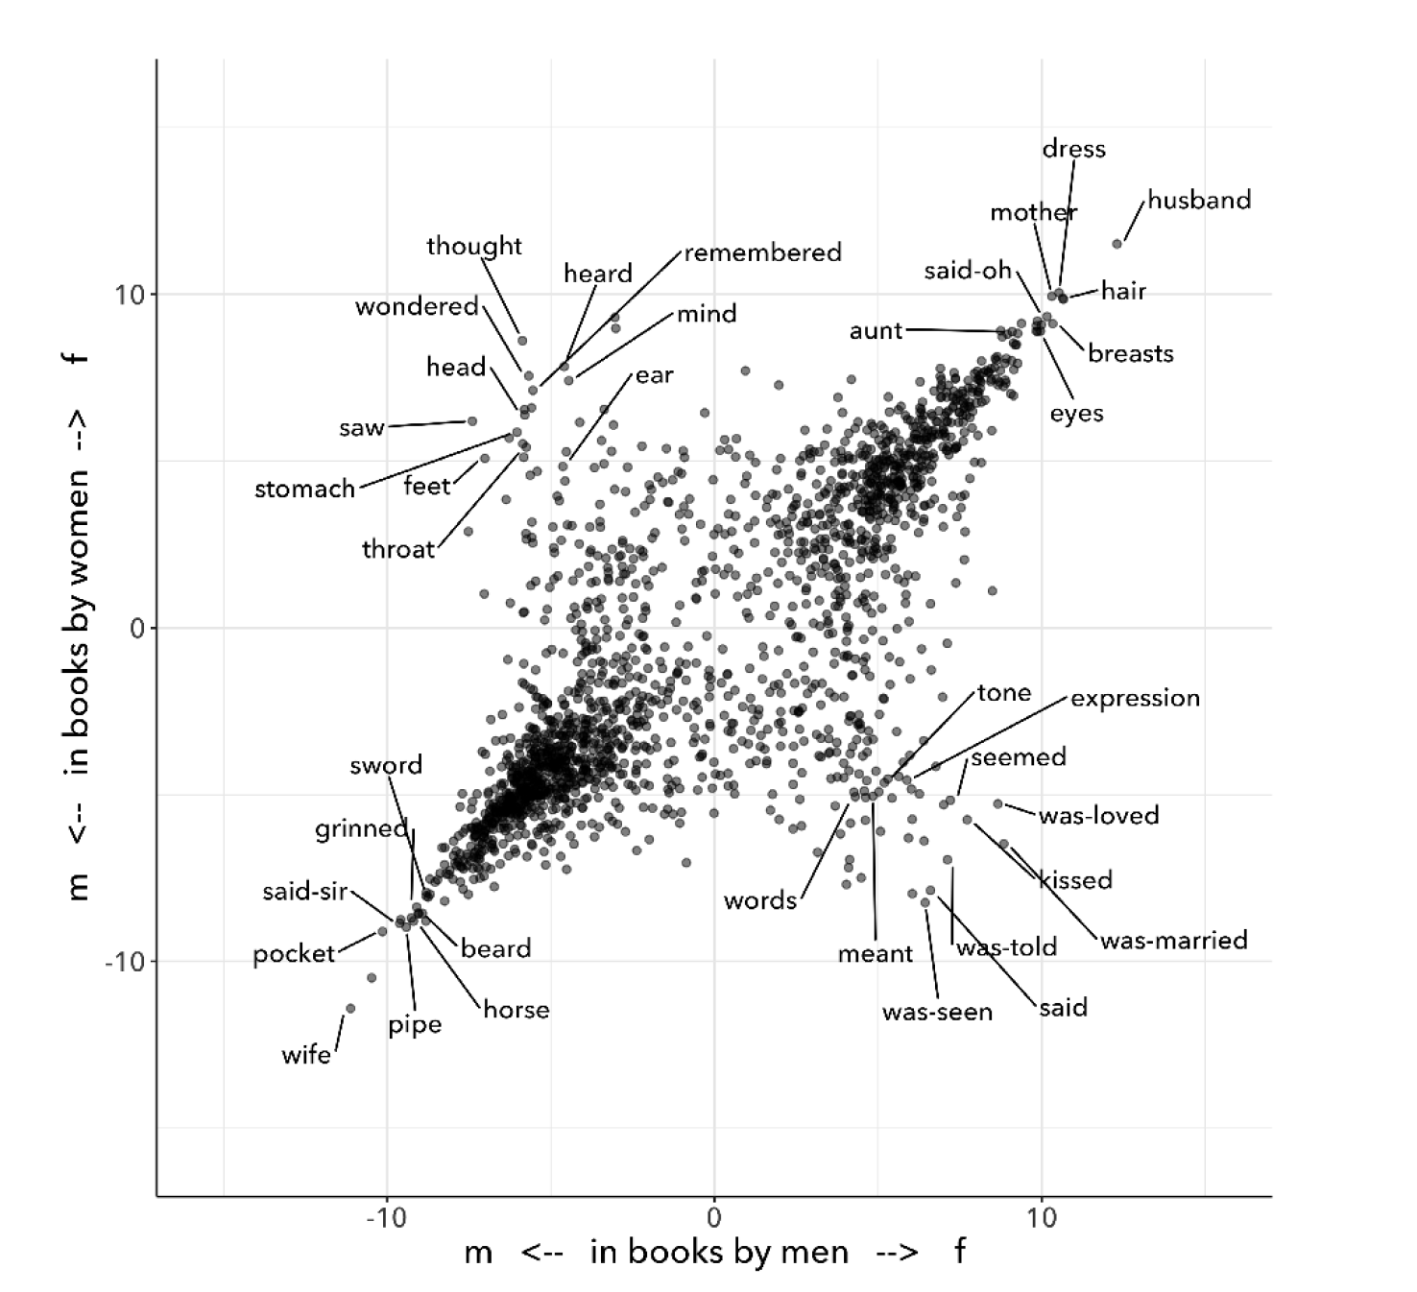

Fig. 1: Underwoods logistic regression model.

Underwood's methodology, however, reinscribes the same binary that it attempts to historicize. Here, he uses uses logistic regression analysis, an entry-level machine learning algorithm that makes predictions on a scale from 0 to 1. The problem is that this probabilistic computation reifies gender as either/or, in other words, as a binary opposition, which Underwood admits himself when he says that "gender theorists will be frustrated by the binary structure of the diagram" ("Machine Learning" 98). Here, the concept of femininity is deliberately consolidated and computed against that of masculinity, which is precisely the purpose of a binary classification algorithm–to collapse all possible answers between a scale of yes/no. Feeding gender terms into such an algorithm effectively imposes a binary structure onto those terms.

In my view, such an approach undershoots the potential of quantitative methods for studying gender, not to mention the goal of attaining some kind of overarching knowledge about literary history, whether that be a "distant horizon" or "the great unread." Distant reading methods might instead harness what Ramsay describes as "the objectivity of the machine," to destabilize the binary (x).[8] Resisting the temptations of falsifiable criticism, work by critics like Susan Brown, Laura Mandell, Richard Jean So, and Edwin Roland apply distant reading methods toward deconstructing social categories like gender and race. Brown and Mandell explain that, "The goal is to acknowledge the subjective effects of belonging to an identity constituted historically through oppression without believing that the identity itself exists independently from historical conditions" (Mandell and Brown 6).[9] This position places computational methods within a discursive frame, aligning it with debates from post-structuralist feminist theory that explore and provoke the representative capacities of language. The computer becomes a tool for exploring how language constructs (and can deconstruct) social categories.

In a critique of distant reading methods, Mandell illustrates how the study of gender often reifies gender stereotypes, "presenting conclusions about 'male' and 'female' modes of thinking and writing as if the M/F terms were simple pointers to an unproblematic reality, transparently referential and not discursively constituted" (par. 5). Mandell's examination marshals key findings from feminist theory, drawing from Judith Butler, among others, to assert that gender is "constructed both by the measurer and the measured" (par. 38). Computation offers, in Mandell's words, "parallax, multiple perspectives for viewing a very complex reality” (par. 38). To deconstruct gender, Mandell turns to genre, another category which will allow scholars to see the reductive constitution of categories generally. Here, Mandell uses the popular stylometry measurement, "Burrow's Delta," which visualizes the "distance" between writing styles by creating branches (or "deltas") between different texts. She finds that the stylistic qualities of a female writer, Mary Wollstonecraft, shares with those of comparable male writers: "Wollstonecraft’s sentimental anti-Jacobin novels most resemble [William] Godwin’s sentimental anti-Jacobin novels… whereas her essays most resemble [Samuel] Johnson’s writings" (par. 29). Drawing gender into conversation with genre, Mandell creates categories such as "'men writing as men,' 'women writing as women,' 'women writing as men,' 'men writing as women,' 'unspecified (anonymous) writing as men,'" and so on (par. 35).

Just as quantification can be harnessed to deconstruct the M/F binary, so it can deconstruct what Edwin Roland and Richard Jean So describe as "the machine's initial binary understanding of race" (68). Roland and So deconstruct racial categories by experimenting with an algorithm that evaluates an author's race based on diction. Analyzing a large corpora of novels by white and black authors, they find that, black authors generally display more varied vocabulary than white authors (66). From this result, they infer that white authorship, as a category, only coheres against the variance of black authorship. Whiteness, they explain, *depends* on the characterization of blackness.

This quantitative exercise points Roland and So toward a peculiarity in the results: that the algorithm wrongly categorizes James Baldwin's novel *Giovanni's Room* (1956) as being written by a white author. This misclassification is attributable to a single word, "appalled," which the computer (mistakenly) reads as proof of white authorship. Going back to the text, Roland and So discover that this term occurs only once, in an early scene where the narrator David describes his strained relationship to his father: "I did not want to be his buddy. I wanted to be his son. What passed between us as masculine candor exhausted and *appalled* me" (my emphasis; Rpt. in Roland, So 71). Noting the connotations of whiteness in "appalled," which has the middle French root, "apalir," meaning "to grow pale," Roland and So posit that this term suggests a relation between gender and race: "the moment David develops a troubled relationship to normative masculinity [as] also the moment he becomes 'white'" (71). The computer's misclassification, as they point out, reinforces this text's notorious elision of explicit references to race, as critics have observed in the scholarship on this novel, whereby racial markers are displaced in favor of an implicit whiteness. Taking the computer's mistake as a starting point, Roland and So's analysis thus contributes to the ongoing debate about the complex relationship between gender and race in the novel.

Because race is a social construct, and machines only impute meaning that is encoded into them, Roland and So reason that machines are ideal instruments for studying the construction of race (60). In direct opposition to the "falsifiable" position, computational error here becomes a starting point for analysis. Furthermore, the machine error surfaces a yet unexplored aspect related to race, that of sexuality:

Our reading’s destabilization of the machine’s logic of white and black arises directly from the novel’s expression of queerness. By queering the machine’s color line, Baldwin’s novel challenges our initial classifications of the novels as white or black, which had necessarily effaced a more sophisticated, intersectional view of social identity. In their current form, our data and model are not robust enough to handle this kind of intersectionality. 72

Like Mandell, So and Roland use computational methods to destabilize, rather than reify, binary categories like male/female, or white/black. In this case, a single computational error opens a site for speculation about how whiteness suggests a troubled understanding of sexuality, where queerness might articulate with race.

## **Iteration**

Mandell asserts that both gender and genre "are… highly imitatable," so that "anyone can adopt gendered modes of behavior, just as anyone can write in genres stereotypically labeled M/F" (par. 30). While this interpretation echoes a common misunderstanding of Butler's theory (explained further below), gender performativity remains a useful heuristic for quantitative text analysis. First, the common misreading of Butler's theory is that gender performativity denotes an act or series of acts that can be imitated at will.[10] Rather, as Butler emphasizes in her follow up book, *Bodies that Matter: on the Discursive Limits of Sex* (1996), performativity is a compulsory process that precedes and constitutes subjectivity–it is a mechanism through which the subject can emerge: "a process of reiteration by which both 'subjects' and 'acts' come to appear at all" (*Bodies* xviii). Butler here makes the argument for gender as purely discursive, where what is experienced as the physical body, from sex to sexuality, only materializes through the repetition of gender norms in which each act signals a prior, authorizing norm.[11] This thread of discursivity, and its implications within a larger trajectory of Queer Studies, is picked up again in this chapter's conclusion.

To better understand performativity as a discursive phenomenon, it is helpful to situate Butler's work within the context of second-wave feminism and its deconstruction of gender binaries. Here, Butler draws from the work of feminist theorist Luce Irigaray, who asserts that influential Western thinkers like Plato, Aristotle, and Freud have defined feminity "on the basis of masculine parameters" (Irigaray, *The Sex Which Is Not One* 23).[12] Irigaray argues that the association of "woman" with "matter" (associated to binaries such as "rationality/emotion" and "mind/body"), and its subordination to male "form" erases the possibility of representing woman at all. Rather, this binary "produces the feminine as that which must be excluded for that economy to operate" (Butler, *Bodies* 10). This "domesticated" feminine term contrasts to the excessive feminine, the "necessary outside" of the domesticated feminine (which is also its enabling condition), that creates a "field of disruptive possibilities" (Butler, *Bodies* 13). However, this "unspeakable" element cannot be invoked directly without subscribing itself to the ruling structure (Butler, *Bodies* 12).[13] Butler asks, "how can one read a text for what does *not* appear within its own terms, but which nevertheless constitutes the illegible conditions of its own legibility?" (*Bodies* 11). This question–how to express what is not there, what is refused by the system of the visible–leads Butler to her theory of gender subversion.

For Butler, theorizing subversion begins by positing the origin of linguistic signification. She wonders, "Can language simply refer to materiality, or is language also the very condition under which materiality may be said to appear?" (*Bodies* 6). Butler finds that, in order to refer to a body, language must first assume a body. Therefore, she reasons, the signification of the body actually creates the body which it appears to reference: "signification produces as an *effect* of its own procedure the very body that it nevertheless and simultaneously claims to discover as that which *precedes* its own action" (6). This reasoning leads Butler to a major realization: "the mimetic or representational status of language…. is not mimetic at all. On the contrary, it is productive, constitutive, one might even argue performative" (*Bodies* 6). If language produces the reality that it seems to merely reference, it means that subjects are always interpellated, and in fact brought into subjectivity, by a discourse prior to their participation in it.

Within this regulatory structure, this significatory circle, lies the possibility of resistance, the possibility of *resignifying* meaning. Because language transcends a merely representative function, because it works to produce meaning, language can be resignified toward subversive usages by "citing" what Butler calls a "repudiated" meaning. Butler offers the famous example in the resignification of the term "queer," which has been transformed from a term of abjection to one of empowerment. "Queer" is resignified when it harnesses its own repudiation, which is an implied but "disavowed abjection [that] will threaten to expose the self-grounding presumptions of the sexed subject" (*Bodies* 3). Each time that "queer" is used, it draws from this domain of abjection which is repudiated by heterosexuality. Butler proposes that one "consider this threat and disruption… as a critical resource in the struggle to articulate the very terms of symbolic legitimacy and intelligibility" (*Bodies* 3). By citing the repudiated meaning, the term "queer" "resignifyi[es] the abjection of homosexuality into defiance and legitimacy" (*Bodies* xxviii).

Here, repetition is key, enabling the introduction of what is external to the binary into the system. Irigaray achieves this resistance by "mim[ing] philosophy… and, in the mime, tak[ing] on a language that effectively cannot belong to her" (Butler, *Bodies* 12). Irigaray undermines authority through repetition, by "cit[ing] Plato again and again, but the citations expose precisely what is excluded from them, and seek to show and to reintroduce the excluded into the system itself" (Butler, *Bodies* 18). Irigaray introduces something external to the system, displacing the logic of phallogocentrism, while remaining within its terminology. Butler imagines Irigaray's thought process here:

I will not be a poor copy in your system, but I will resemble you nevertheless by miming the textual passages through which you construct your system and showing that what cannot enter it is already inside it (as its necessary outside), and I will mime and repeat the gestures of your operation until this emergence of the outside within the system calls into question its systematic closure and its pretension to be self-grounding" (*Bodies* 18).

Through repetition, deception emerges from resemblance, and insubordination through subservience. The key is iteration, a continual miming of the authorizing norm.

In what follows, I examine how iteration also emerges in the Python programming language as it is used for text analysis tasks. Here, I will deconstruct the cleaning and analysis processes to surface the ways that Python's syntax evokes this quality of iteration.

The Python programming language offers a number of custom libraries, such as the Natural Language ToolKit (NLTK), for common text analysis tasks that clean, count, and visualize textual patterns. Python handles text data in the form of words, or strings, contained within groupings called lists. Then, Python goes through each item in the list to perform a task. One way of going through lists is a construct known as the for loop, which repeats a single action to each item, each string, within the list. At a very basic level, much of text analysis consists of looping, or iterating, over bits of text and performing actions to standardize the text for analysis. Such actions include tokenizing, cleaning, and regularizing, which help to eliminate pieces of text that will skew the results of analysis due to their high frequency and low semantic value. Tokenizing the text means separating the text into workable units, or tokens, that are easier to clean and regularize. Once the text is tokenized, it can be stripped of capital letters, punctuation, and what are called "stop words," which consist of prepositions, articles, pronouns, and auxiliary verbs, which are deemed to be semantically minor compared to nouns, verbs, and adjectives, and adverbs. The task of preprosessing text forces words into existing boxes, so to speak, stripping text of the significance portrayed by capitalized words, rhythms of language in stop words, inflections in word endings, and so on. This reduction of text is a necessary trade-off in order to reduce idiosyncrasies and to make meaningful computations on the text, making them amenable to analysis.

The first step in cleaning usually involves removing things like punctuation and capital letters. The following code block loops through a text, saved here as full-text, to filter out punctuation and transform any capital letters into lowercase forms:

normalized = []

for word in full-text:

if word.isalpha():

normalized.append(word.lower())

Here, the loop begins by creating an empty list, normalized, where words will be dropped after passing the filter. The next line begins the for loop, which iterates through each word in the full-text list of words. The third line, an if statement creates a Boolean (a True or False) condition in which only alphabetic characters will pass through (that is, characters which do not contain numbers or punctuation). If the word fulfills this condition, then it passes to the fourth line, which will add that word to the normalized list. At the moment that this word is added to the list, its letters will be transformed into lowercase format. The final list, therefore, will only contain alphabetic and lowercased letters.

The next step is removing stop words. Here, we use another loop, compressed into one line of code, in a syntax that is called a "list comprehension."

no-stops = [word for word in normalized if word not in stops]

This expression takes each word in a list, in this case, normalized, and checks to see if that word is also contained in stops, a list of stop words. If the word is *not* a stop word, then it will be added to a new list, no_stops. Running the first sentence of *Orlando* through the loop will return the following list of words:

['could', 'doubt', 'sex', 'though', 'fashion', 'time', 'something', 'disguise', 'act', 'slicing','head', 'moor', 'swung', 'rafters']

The next (and final) step of cleaning involves stripping word inflections to get the root. Here, there are two possibile choices, which differ in how much computational processing each requires. The first one, called "stemming", simply cuts the endings from the word. For example, "rafters" will be stripped to "rafter." What this method gains in speed, however, it loses in precision, and can sometimes cut letters that are intrinsic to the word. The other possibility, called "lemmatizing," involves looking up each word, one by one, in a dictionary to find its appropriate root. Below is the code for lemmatizing the text:

clean = [WordNetLemmatizer.lemmatize(word, word) for word in no-stops]

At this point, the text is ready for analysis. A good first step is to begin with a target word, in this case, "woman." One useful function, called concordance() returns the context, that is, the immediate words surrounding, the target word. Below, the word "woman" is run through a concordance of the words in *Orlando*:

alities which the old woman loved the more the mo

scarlet . For the old woman loved him . And the Q

les . The old bumboat woman , who was carrying he

h , whether boy 's or woman 's , for the loose tu

boy it must be – no woman could skate with such

eadth off . She was a woman . Orlando stared ; tr

, until now ? An old woman , he answered , all s

and some old country woman hacking at the ice in

and pity the poor old woman who had no such natur

man 's beard and that woman 's skin ; of a rat th

the sight of the old woman hobbling over the ice

ght coming or the old woman or whatever it was ,

tainly not those of a woman bred in a cattle-shed

e world for a Cossack woman and a waste of snow -

erating . There was a woman in white laid upon a

Based off the contexts surrounding the target word, Python can make further analyses. Another method, called similar() returns a list of words used in similar contexts to the target word. To compute the results of similar(), NLTK first takes the context of the target word from concordance(), then it searches the text for other terms which contain the same surrounding words. The result for running similar on the word "woman" is the following:

man moment night boy word world child pen ship door one room window light little lady table book queen king

By searching the text for words that appear in similar contexts to the chosen word, this method might reveal words that have semantic resemblance to the target word. It is important to point out, however, that the computer does not impute meaning to the words. Rather, it only counts each word as a string, that is, as a piece of data composed of alphanumeric sequences. It takes "woman," then notes all of the words in proximity to "woman," and then searches the rest of the text for other words that have similar proximities.

Basic NLP tasks offered by libraries like NLTK contrast with "deep learning" methods that work in more sophisticated ways to count and analyze language. Many of these methods use "word embeddings" to ascribe machine-interpretable meaning to strings. Like similar() and concordance(), word embeddings build off patterns of word similarity based on context. Unlike the NLTK methods, however, word embeddings encode a value (actually, a list of values) to a given word based on its context. The value of any given word is a numerical representation known officially as a "word vector." A vector for a single word, "woman," for example, will contain a list of numbers that represent a similarity score between "woman" and another word. As numerical representations, these values enable further quantitative exercises that can analyze the relationship between "woman" and other words. The classic example for introducing the potential of word vector math is the formula, "King - Man + Woman = Queen" (Mikolev et al. 2). Here, gender (between "Man" and "Woman") is isolated as a computable component which enables one to derive the difference between "King" and "Queen".[14]

For example, the vector which represents "woman" contains a list of numbers that score the similarity "woman" to other words. Here, the word "woman" is most closely associated to the word "child," with a similarity score, or "weight," of .93, or 93%, then with "mother," with .92, then "father," with .90.[15] Below is a word vector of words calculated to be most similar to "woman":

[('child', 0.9371739625930786),

('mother', 0.9214696884155273),

('whose', 0.9174973368644714),

('called', 0.9146499633789062),

('person', 0.9135538339614868),

('wife', 0.9088311195373535),

('being', 0.9037441611289978),

('father', 0.9028053283691406),

('guy', 0.9026350975036621),

('known', 0.8997253179550171)]

Commonly, word embeddings are organized into a matrix, or tabular, format. Using this matrix format, further mathematical operations are possible using statistics, linear algebra, and calculus, which are the building blocks of deep learning methods. In deep learning, the labels accompanying the numerical representations do not matter, only the list of numbers themselves, which together represent the word vector. The word "woman," therefore, would be represented with the following vector: .937. .921, .917, .915, .914, .909, and so on. This representation demonstrates that, even when removing labels, words are still assigned meaning by their relation, their proximity, to other words. In the following section, I use these word vectors as a starting point to explore terms related to each gender in *Orlando*, starting with the terms "woman" and "man."

## **Queer Distant Reading**

I now turn to Virginia Woolf's novel, *Orlando: A Biography*. This novel is ideal for a computational study of gender for two reasons. First, published in 1928, it is perhaps the earliest salient example of transgender narrative. Second, as many critics have noted, its characteristic modernist experimentation with limits of language works toward destabilizing normative concepts of identity and gender. Jane de Gay, Jill Channing, and Christy L. Burns, for example, assert that Woolf deploys imaginative elements, magical realism, and parody, respectively, to resist realist narrative expectations. De Gay describes Woolf's writing as "feminist historiography" that "reject[s] Victorian patriarchal metanarratives" and instead "use[s] the strategies of fiction to bring history alive and make it live in the present" (de Gay 71). In a similar vein, Burns and Channing both point out that Woolf uses fantastical elements, in the former in the service of parody, and the latter as part of magical realist writing, that disrupt expectations of plot and narrative to challenge the stability of gender and identity. Doubling down on the role of language, some critics emphasize that the narration purposefully obfuscates any coherence between gender, identity, and even race and nationality. For example, Victoria L. Smith asserts that "The fantastic content in the novel is directly linked to the undecidability/impossibility of the form of the novel and of the protagonist" (58). Pamela Caughie analysis agrees, arguing that *Orlando*'s transgressiveness comes from its discursive moves: "Far from defeating sexual difference, as many feminist critics claim, Orlando enacts it, enshrines it, exploits it, makes a spectacle of it, but as a playful oscillation not a stable opposition" (Caughie 48).

In what follows, I pursue a text analysis method that I call "iterative" for the way it moves between close and distant reading, a process similar to what Andrew Piper calls "bifocal" reading. This process, in Piper's words, "no longer us[es] our own judgments as benchmarks… but explicitly construct[s] the context through which something is seen as significant (and the means through which significance is assessed)" (17). My method feeds the output of computations into close reading analysis, using the computer to identify words that I then examine in context and with detail.

First, I begin with a list of terms computed similar to woman and man in the text. Unlike the word embedding of "woman," from my previous section, the embeddings here are trained on Woolf's novel, and therefore reflect an understanding of gender markers based on this specific text. Additionally, to get distinctive results for each gender, I modified the code to remove any words with strong associations to the opposite gender. For example, I compute words that are most positively associated with "woman" and most negatively associated with "man." Though this analysis, like Underwood's, begins with a binary formulation of gender, this binary quickly destabilizes as I move deeper into the close reading analysis, more like Richard Jean So and Edwin Roland's study of race. By *iterating* through distant and close reading, the terms swell with significations that pluralize the binary and work toward resignifying the initial results for "woman" and "man." Below are the word embeddings for the term "woman" and "man," respectively.

distinct_w = model.wv.most-similar(positive="woman", negative="man")

[('soft', 0.3692586421966553),

('named', 0.34212377667427063),

('sciatica', 0.3223450779914856),

('frilled', 0.3187992572784424),

('despaired', 0.31375786662101746),

('friend', 0.31238242983818054),

('delicious', 0.30853813886642456),

('winked', 0.30514153838157654),

('notion', 0.3047487139701843),

('seductiveness', 0.30290719866752625)]

distinct_m = model.wv.most-similar(positive="man", negative="woman")

[('chequered', 0.4025157392024994),

('fact', 0.3394489586353302),

('denounced', 0.3346075117588043),

('house', 0.33423593640327454),

('curiosity', 0.33144116401672363),

('defend', 0.3284823000431061),

('dancing', 0.3282632827758789),

('marbling', 0.3184848427772522),

('cynosure', 0.3057470917701721),

('rather', 0.3024100363254547)]

At first glance, the terms for each list appear to align with existing conceptions of femininity and masculinity, such as "soft" and "frilled" for "woman," and "fact" and "defend" for "man." But as I examine these words in context, the gender binary becomes less clear cut. From the "woman" list, I examine the term "delicious," which only appears after Orlando has transitioned into a woman in the story. As I explain below, this term reveals a relationship to queerness characterized by what I describe as a distinctly feminine mode of resistance. Then, from the "man" list, I examine a term that only appears once in the novel, at a significant moment which initiates what I call the novel's "crisis of signification" with language. Following this thread, I examine further passages that develop this theme as it spreads into Orlando's interior narration. I conclude with a close reading of a rather dramatic passage that contains words from both the "woman" and "man" lists, and constellates this crisis with themes of gender ambiguity and homosexual desire.

I begin with the word "delicious," which occurs only after Orlando transitions into a woman. Three of this term's five occurrences appear in a single passage, when Orlando is sailing from Turkey back to her native England. The ship captain offers Orlando a bit of beef, which sends her into a rapturous speculation about the joys of womanhood:

'A little of the fat, Ma'm?' he asked. 'Let me cut you just the tiniest little slice the size of your fingernail.' At those words a *delicious* tremor ran through her frame. Birds sang; the torrents rushed. It recalled the feeling of indescribable pleasure with which she had first seen Sasha, hundreds of years ago. Then she had pursued, now she fled. Which is the greater ecstasy? The man's or the woman's? And are they not perhaps the same? No, she thought, this is the most *delicious* (thanking the Captain but refusing), to refuse, and see him frown. Well, she would, if he wished it, have the very thinnest, smallest shiver in the world. This was the most *delicious* of all, to yield and see him smile. 'For nothing,' she thought, regaining her couch on deck, and continuing the argument, 'is more heavenly than to resist and to yield; to yield and to resist. 114

Here, "delicious" describes a refusal, then a yielding–the vacillations of what appears to be a passive form of pleasure, ostensibly opposed to the active pleasure of pursuit which Orlando enjoyed as a man. Below, I will return to this active kind of pleasure, and the scene of its emergence when Orlando meets Sasha. Here, although the word "delicious" describes a distinctly feminine experience of pleasure, about withholding and, eventually, submitting to the active force, it is a pleasure rooted in what is not quite passivity and not quite power.

To get a deeper understanding of this term, I run another similarity search with "delicious" as the target word. The top result, the word most related to "delicious" in the text, is "culpable." I then turn back to the text to examine when this word appears, which happens twice, both times in the same scene on the ship, during Orlando's ruminations about the pleasures between the sexes. Here is one of the few times in the novel that Orlando considers her homosexuality explicitly:

And as all Orlando's loves had been women, now, through the culpable laggardry of the human frame to adapt itself to convention, though she herself was a woman, it was still a woman she loved; and if the consciousness of being of the same sex had any effect at all, it was to quicken and deepen those feelings which she had had as a man. 119

"Culpable," from the Latin "culpa," meaning fault, denotes a body deserving of blame for its refusal to conform. Here, the word modifies "laggardry," which describes the obstinacy or persistency of Orlando's love for women, despite that she is now a woman herself. It seems that, for Orlando, desire is defined by a sense of guilt about refusing to conform. The next usage of this term occurs soon after, when Orlando reprises her earlier thoughts around the time that "delicious" appeared:

'To refuse and to yield,' she murmured, 'how delightful; to pursue and conquer, how august; to perceive and to reason, how sublime.' Not one of these words so coupled together seemed to her wrong; nevertheless, as the chalky cliffs loomed nearer, she felt culpable; dishonoured; unchaste, which, for one who had never given the matter a thought, was strange. 120

Rehearsing the conventional roles of the sexes, roles which Orlando fails to fit into, she feels (in addition to "culpable) "dishonour[ed]" and "unchaste"–words associated with an ideal of virtuous femininity. This feminizing language deepens the relationship between desire, guilt, and deliciousness, the last of which was previously characterized as a distinctly feminine pleasure in passivity that is not quite powerless. Here, Orlando's refusal to conform, for which she feels culpable, constitutes another kind of passivity, a form of refusal. The connection between "delicious" and "culpable," seem to define queer desire as a distinctly feminine mode of resistance.

Now, I move to Orlando's experience as a man, returning to the original list of similar terms. I begin with "chequered," which appears only once, at the very beginning of the story, when Orlando makes his entrance, stepping into "the yellow pools chequered by the floor" (12). This moment is the first of many in which the narrator calls into question his credibility as a biographer, a self-described "scribe," who distinguishes his role from that of the poet that embellishes and exaggerates through figurative language. However, the narrator's commitment to straightforward description soon gallops into full-fledged figuration when he tries to describe Orlando's beauty:

Directly we glance at Orlando standing by the window, we must admit that he had eyes like drenched violets, so large that the water seemed to have brimmed in them and widened them; and a brow like the swelling of a marble dome pressed between the two blank medallions which were his temples. Directly we glance at eyes and forehead, thus do we rhapsodize. Directly we glance at eyes and forehead, we have to admit a thousand disagreeables which it is the aim of every good biographer to ignore. 12-13

Here, the narrator's evocative language undermines the pretense to objectivity which he feels so compelled to produce a few lines above this one. This slip into figurative language eventually grows into a crisis of signification that recurs persistently through the novel.

The crisis even spreads to Orlando's internal thoughts, where it first emerges during a period of depression following his love affair with Sasha, a Russian princess. Here, I take the term, "despaired" which, like "chequered," occurs only once in the novel:

So then he tried saying the grass is green and the sky is blue and so to propitiate the austere spirit of poetry whom still, though at a great distance, he could not help reverencing. 'The sky is blue,' he said, 'the grass is green.' Looking up, he saw that, on the contrary, the sky is like the veils which a thousand Madonnas have let fall from their hair; and the grass fleets and darkens like a flight of girls fleeing the embraces of hairy satyrs from enchanted woods. 'Upon my word,' he said (for he had fallen into the bad habit of speaking aloud), 'I don't see that one's more true than another. Both are utterly false.' And he despaired of being able to solve the problem of what poetry is and what truth is and fell into a deep dejection. 75

Orlando, deep in depression, struggles to understand the role of figuration in language. Much like the narrator in the previous passage, Orlando also questions the truthfulness of figurative elements. First, he attempts plain language, "the sky is blue", "the grass is green," but these prove insufficient for describing a sky that moves "like the veils which a thousand Madonnas have let fall from their hair" and grass that "fleets and darkens like a flight of girls fleeing the embraces of hairy satyrs from enchanted woods." Orlando, who has just been abandoned by a woman, sees in nature flight and modesty, qualities which he finds "false."

In a final example, I examine the co-occurrence of words from both lists within a single passage, the scene where Orlando meets Sasha. The words, "curiosity," which is associated with "man," and "seductiveness," which is associated with "woman," appear in a moment of tumultuous desire about Sasha's gender incomprehensibility, where gender becomes intimately coordinated to language's ability to signify. The drama begins when Orlando, upon seeing Sasha for the first time, cannot tell whether she is a man or a woman:

He beheld, coming from the pavilion of the Muscovite Embassy, a figure, which, whether boy's or woman's, for the loose tunic and trousers of the Russian fashion served to disguise the sex, filled him with the highest *curiosity*. The person, whatever the name or sex, was about middle height, very slenderly fashioned, and dressed entirely in oyster-coloured velvet, trimmed with some unfamiliar greenish-coloured fur. But these details were obscured by the extraordinary *seductiveness* which issued from the whole person. Images, metaphors of the most extreme and extravagant twined and twisted in his mind. He called her a melon, a pineapple, an olive tree, an emerald, and a fox in the snow all in the space of three seconds; he did not know whether he had heard her, tasted her, seen her, or all three together. (For though we must pause not a moment in the narrative we may here hastily note that all his images at this time were simple in the extreme to match his senses and were mostly taken from things he had liked the taste of as a boy. But if his senses were simple they were at the same time extremely strong. To pause therefore and seek the reasons of things is out of the question)… A melon, an emerald, a fox in the snow–so he raved, so he stared. When the boy, for alas, a boy it must be–no woman could skate with such speed and vigour–swept almost on tiptoe past him, Orlando was ready to tear his hair with vexation that the person was of his own sex, and thus all embraces were out of the question. 27-28

The passage constellates the crisis of signification within the larger issue gender ambiguity. Orlando uses seemingly arbitrary metaphors, "A melon, an emerald, a fox in the snow," indicating that at the same time which he cannot place Sasha's gender, he also cannot find the right words to describe her. As Sasha's gender oscillates between male and female throughout the passage, so the narrative voice alternates between Orlando's interiority and the narrator's commentary. Taking this crisis of signification to the level of dietic narrative, the narrator's "pause" indexes the constructed nature of the scene. This constructed quality is reinforced by the narrator's attempt to explain Orlando's choice of words to describe Sasha, which have no "reason," and "were mostly taken from things he had liked the taste of as a boy." Language, like gender, thus becomes a tool for representation and performance. As Pamela Caughie, asserts, the gender transgression is intimately connection to the narrator's experiments in figuration and form: "Woolf brings out the arbitrariness of [sexual] identity, the arbitrariness of language itself, through Orlando's switching from one sex to the other, and from one poetic language to another, as well as through the shifting of her own rhetoric in this novel (42). This passage, with its "switching" and "shifting" discourse, which asserts that word choices are arbitrary and flowing, implies that gender is also a fluid phenomenon.

## **Conclusion**

The argument that *Orlando*'s subversiveness is a discursive one, opens the text to numerous critiques[16], particularly from Trans Studies. According Jay Prosser, Woolf's experimentation with language and narrative form belies the physical the embodied reality of transsexuality. He argues that "Orlando is not about the sexed body at all but the cultural vicissitudes of gender. As h/er narrative propels h/er through four centuries of history, Orlando is free to move beyond h/er body–quite queerly, to break through the limits of the flesh" (Prosser 168). By "the sexed body," Prosser means the physical body which is bound by the physical and social world. *Orlando's*'s transgressiveness results from a play of language and literary form that elides the specificity and the lived reality of the "sexed body." Rather, due to its "ambivalence, a wavering around transition", "a transformation of transition into new identity," its "easy androgyny," this text is transgender (Prosser 169).

A decade later, Omise'eke Natasha Tinsley writes about the problem of gender fluidity as a metaphor. In her essay, "Black Atlantic, Queer Atlantic: Queer Imaginings of the Middle Passage," Tinsley argues for the imbrication of sexuality and race through the lens of the Black Atlantic. By sexuality, Tinsley does not necessarily mean "same-sex" desire, but relationships from the Middle Passage, that "mak[e] disruption to the violence of the normative order… connecting in ways that commodified flesh was never supposed to" (199). Reading for relation rather than desire, her critique re-works the trope of fluidity which, drawing from the ocean, "is not an easy metaphor or queer and racially hybrid identities but for concrete, painful, *and* liberatory experience" (192-193). For Tinsley, fluidity is an opportunity for "a return to the materiality of water to make its metaphors mean more complexly, shaking off settling into frozen figures" (212). Reading from Dionne Brand's book, *Map to the Door of No Return* (2001), on the Middle Passage, Tinsley theorizes fluidity as a "social liquidation," being stripped by the water, particulars of identity washed away in the current. She explains that "brown bodies are gender fluid not because they choose parodic proliferations but because they have been 'washed of all this lading, bag and baggage'" (209).

Tinsley's critique surfaces the ways that gender fluidity, as a trope for queerness, obscures the very physical connotation of corrosion. While this chapter, following Butler, has proposed iterativity, which is a form of fluidity, as a kind of enabling constraint that creates a possibility for resistance, I wonder how Tinsley's evocation of materiality might deepen this analysis, opening the potential of Queer Studies-inflected frameworks for text analysis. One might think more deeply about the concept of iteration and its connection to the productive power of language, the ways that language physically executes action, for example, in computer code. Python differs from other languages (like markup languages HTML and XML, which I explore in the next chapter) in that it is an executable language. The code not only defines instructions, but also enacts them. How might this active quality of Python programming influence the way that we study gender as an active, embodied phenomenon?

# CHAPTER TWO

# “‘Where there is Spectacular Passion, they would Suggest Something Vile’: Encoding Queer Erasure in Oscar Wilde’s The Picture of Dorian Gray”

## **Introduction**

In the first scene of the novel, The Picture of Dorian Gray (1891), the painter Basil Hallward confesses to his friend Lord Henry Wotton why he cannot exhibit his portrait of the eponymous hero. Basil admits, "Where there is merely love, they would see something evil, where there is spectacular passion, they would suggest something vile" (Wilde 21). This striking line never appears in print. It is excised during Oscar Wilde's revision process, along with similar suggestions of homoeroticism between the three main characters of the story.

The textual scholarship on this revision process generally agrees that Wilde neutralizes Basil's erotic fascination with Dorian by transforming it into aesthetic appreciation in order to get by the censors. Like these lines from the text's "Preface," which was included with the book version published in 1891: "To reveal art and conceal the artist is art's aim," and "Those who find ugly meanings in beautiful things are corrupt without being charming." One critic, Nicolas Ruddick, explains that Wilde's revisions for this text create a double moral, one about beauty and one about sexuality. According to Ruddick, Wilde revisions increasingly aestheticize Dorian in order to emphasize a moral about the dangers of vanity at the expense of another, more covert moral about the liberalization of homosexuality. While the moral about vanity "dramatize[s] the disastrous consequences of the preference of the beautiful at the expense of the good," the other moral about homosexuality "explores the destructive effects of the clandestine or closeted life" (Ruddick 126, 128). The portrait indexes the convergence of these two morals: "the appalling changes to Dorian's painted image … strongly suggest that the unspeakable practices indulged in by the protagonist are unspeakable in themselves" (Ruddick 129).

The question of what is "unspeakable," and why, about the homosexual content in Oscar Wilde's text is the topic of this chapter. To explore these revisions, I use a digital editing tool to mark and categorize them according to themes like "passion," "beauty," "intimacy," and "fatality." What begins as textual editing project eventually expands into an interrogation of the tool, the Text Encoding Initiative (TEI). I explore how the rigid, hierarchical structure of the TEI's data format, which works best with material that is discrete, and can be separated into distinct elements, handles the smooth data of Wilde's revisions in this text.

My project endeavours to answer a question posed by literary and electronic textual scholar Julia Flanders: "do we need to queer markup, or is markup already queerable?" ("Encoding Identity"). Flanders's question considers the TEI's place between two current approaches in Queer DH: the first approach wants to disrupt formal systems by imagining alternative ones, and the second, by contrast, maintains that queerness is built into computing and is inherent in computational logic.[17] In an attempt to cut between these debates, this project first searches for a structural constraint within the TEI format then works through this constraint to analyze the homoerotic elements in Wilde's manuscript revisions. As such, this project aligns with Jason A. Boyd's Texting Wilde Project, which uses the TEI to interrogate Wilde's textual and historical legacy. Boyd's project, which marks up the biographical information, particularly references to persons, places, and events, in writings about Wilde's life, reveals historical discrepancies and inaccuracies across Wilde's biography. Boyd points out that "Our knowledge of 'Oscar Wilde' is not comprised of a corpus of pure and simple facts that allows us an unmediated apprehension of a real person separated from us by only time, but rather this knowledge is comprised of a densely complex and often contradictory accretion of texts" (Boyd para. 1).

My project also uses the TEI to complicate the understanding of Wilde's textual legacy. It identifies one major constraint of the TEI: that it works best with data that is discrete, rather than smooth data, like the homoeroticism obscured by Wilde's pen. Here, I apply the rigid constraint of the TEI data structure towards marking up and analyzing this text's homoeroticism, which I group into the general themes of "intimacy," "beauty," "passion," and "fatality," as well as the pen strokes that Wilde uses to strike these elements from the text. The functionality of the TEI as a tool that bounds and labels data into discrete elements allows me to explore the indeterminate boundaries of these queer themes in the text. It also suggests, on a deeper level, how dominance structures work to implicitly delimit what can and cannot be encoded into its format.

## **Textual Scholarship and Queer Historiography**

To inform my approach for handling homoerotic subject matter within digital contexts, I bring Textual Scholarship and Queer Historiography into conversation. Between these two fields, I identify a parallel debate between what I term the "restorative" and "productive" approaches to critical analysis.

The history of Textual Scholarship first tends toward the restorative approach, beginning with the work of Shakespearean scholar Ronald B. McKerrow, who maintains that the goal of scholarly editing is to preserve authorial intention. McKerrow's influential model for "copy-text" editing, which establishes the base-text for editing on an early witness that most closely resembles the author's original intention, gives way to Walter W. Greg's approach that expands the purview of critics to more than a single witness. Subsequently, textual scholars like Fredson Bowers and Thomas Tanselle advance Greg's work, proposing the "eclectic edition" as the format that enables the editor to distil authorial intention from multiple sources. Tanselle in particular takes this principle to its logical conclusion, arguing that the "work" exists in an ideal form, beyond the reach of physical corruption:

Those who believe that they can analyze a literary work without questioning the constitution of a particular written or oral text of it are behaving as if the work were directly accessible on paper or in sound waves … its medium is neither visual nor auditory. The medium of literature is the words (whether already existent or newly created) of a language; and arrangements of words according to the syntax of some language (along with such aids to their interpretation as pauses or punctuation) can exist in the mind, whether or not they are reported by voice or in writing. Tanselle 16-17

Tanselle's position enshrines the editor as the only figure capable of realizing the "work" in its ideal form. Because the act of inscription involves physical tools that can corrupt this ideal form, the writer requires an editor whose distance from the creation of the work enables his objective evaluation of its intention. This quite radical view for preserving authorial intention exemplifies an extreme take on the restorative approach.

If the restorative approach promotes editorial practices that increasingly consign the role of the editor as a recoverer of authorial intention, the productive approach empowers the editor to imagine its multiple forms. Toward the end of the 20th century, textual scholar D. F. McKenzie's ideas about "the sociology of texts" were the first to widely challenge the claim that a single text can represent an "ideal" version, that is, authorial intention. According to McKenzie, the text is never one single object, but stems from a number of human agencies and mechanical techniques that are historically situated, pointing out that "Every society rewrites its past, every reader rewrites its texts, and if they have any continuing life at all, at some point every printer redesigns them" (McKenzie 25). Jerome McGann expands this sociological perspective into digital editing environments, where electronic formats create opportunities for presenting textual variation. McGann explains that textual criticism in print format is limited because a print text must conform to the linear and two-dimensional form of the codex–the same form as its object of study. Digital editions, by contrast, can be designed for complex, reflexive, and ongoing interactions between reader and text. McGann notes that his work on the digital Rossetti Archive brought him to repeatedly reconsider his earlier goals, explaining that the archive "seemed more and more an instrument for imagining what we didn't know" (McGann 82). This approach counters the traditional fidelity toward authorial intention with a drive to harness the potentiality of textual variation. The transformation of literary material into electronic format becomes a vehicle for a critical analytical method that McGann and Lisa Samuels call "deformative criticism," which works by distorting, disordering, or re-assembling literary material in order to estrange the reader from their familiarity of the text. Continually subscribing the text to new configurations, this estrangement confronts the reader with new insights about its formal significance and meaning.

The textual scholarship of Wilde's revisions fits into the restorative approach. Here, textual scholars Donald Lawler, Joseph Bristow and Nicolas Ruddick claim that Wilde's revisions work toward the overall goal of aestheticizing the text. This project of aestheticization begins in the manuscript which is eventually published in Lippincott's Monthly Magazine on June 20, 1890.[18] This first printing of 'The Picture of Dorian Gray,' which spans 98 pages over 13 chapters, was widely criticized in the press for its seemingly ambiguous stance on an immoral protagonist. Bristow explains that "[Wilde's] narrative struck the [reviewers] as a work that appeared 'corrupt,'" displayed "effeminate frivolity," and dealt "with matters only fitted for the Criminal Investigation Department" (xviii). Wilde spends the next several days defending his work in letters to the editors of numerous newspapers.[19] A few months later, in early spring of 1891, Wilde publishes a "Preface" that makes such claims as "To reveal art and conceal the artist is art's aim."[20] Barbara Lecklie asserts that, by these complex and incisive statements, "Wilde's strategy is to refocus on art and disparage the focus on the reader by saying that the reader is the one who makes a work immoral" (173). Similarly, Lawler argues that "the 'Preface' … hold[s] up aesthetic beauty and artistic effect as the only legitimate criteria of critical evaluation" (16). The "Preface" is included in the subsequent iteration of Dorian Gray, published in a book version by Ward, Lock & Company in April 1891. According to the editor of the Uncensored Edition of Dorian Gray, Victor Frankel, Wilde here makes significant deletions of passages referencing homosexuality, promiscuous or illicit heterosexuality and "anything that smacked generally of decadence" (47-48). Wilde also "heighten[s] Dorian's monstrosity toward the novel's conclusion "to bring the story to a moral conclusion that he thought would silence his critics" (Frankel 30).

Like Textual Scholarship, the field of Queer Historiography has also engaged in debates about methodologies for recovery. Susan McCabe describes "Queer Historiography" as the "critical trend of locating 'identifications' (rather than identity), modes of being and having, in historical contexts" (McCabe 120). Within this field, there is a debate about the extent to which critics in the present can adequately define queerness in the past. The Queer Historicist position advocated by scholars like David Halperin and Valerie Traub maintain that homosexuality is historically constructed, that "queerness" means something different today than it did in the past, and that scholars can get at its meaning by employing a Foucauldian genealogical method that traces its meaning over time. Identity based on sexuality, according to Halperin, is a modern cultural production: "no single category of discourse or experience existed in the premodern and non-Western worlds that comprehended exactly the same range of same-sex sexual behaviors … that now fall within the capacious definitional boundaries of homosexuality" (Halperin 88). Valerie Traub explains that the utility of the word "queer" as a descriptive term relies on historical specificity:

Queer's free-floating, endlessly mobile, and infinitely subversive capacities may be strengths—allowing queer to accomplish strategic maneuvers that no other concept does—but its principled imprecision implies analytic limitations … if queer is intelligible only in relation to its social norms, and if the concept of normality itself is of relatively recent vintage (Locherie), then the relations between queer and the changing configurations of gender and sexuality need to be defined and redefined. 33

When "queer" is applied ahistorically, it loses its descriptive value. In order to be legible, homosexuality needs historical specificity.

By contrast, the "unhistoricists" are wary of demarcating queer identity and identification across history. These scholars, who include Jonathan Goldberg, Madhavi Menon, and Heather Love, maintain that the attempt to define "queer" implicitly subscribes queerness to a logic of progress, a heteronormative teleology. According to Goldberg and Menon, historicizing queerness can have the unintended effect of normalizing queerness: "to produce queerness as an object of our scrutiny would mean the end of queering itself" (1609, 1608). Heather Love suggests methodology that she calls "feeling backward," which takes negative histories and affects (like shame, disappointment, and anger) without attempting to "fix" them into contemporary conceptions of identity and desire. Rather, Love is interested in exploring the way that subjects turn away or refuse the critic's attempt to "redeem" or "rescue" them. To illustrate this process of "feeling backward," she offers the myth of Orpheus and Eurydice, pointing out that Orpheus prefers to behold Eurydice in the darkness of the Underworld rather than in the sunlight, which would transform her into something fully accessible and therefore less desirable.[21] Love, who asserts that "Queer history has been an education in absence" (52), points out that "[Eurydice's] specific attraction for queer subjects is an effect… of a historical experience of love as bound up with loss. To recognize Eurydice as desirable in her turn away is a way of identifying through that loss" (51). For Love, accepting queerness as something that eludes containment reinforces queerness as something that escapes knowability.

On the restorative side, the impulse to recover authorial intention resembles the drive to historicize queer identification, as both are motivated by the idea of an accessible past. On the productive side, deformative criticism plays on the same creative instinct as "feeling backward," which Love describes as "a mode of historiography that recognizes the inevitability of a 'play of recognitions'" 45). The impossibility of recovering the past enables the critic to experiment, or "play" with, alternative methods of analysis. By attending to elusive affects without trying to transform them into something more palatable, one may, borrowing from McGann and Samuel's idea of deformance, reconceive textual editing as a formal experiment. In what follows, I examine the TEI as a data format, with the goal of exploring how it might be used to impose new formal structures on the queer subject matter in Wilde's text.

## **TEI**

Created specifically for working with literary material, the TEI enables researchers to transform print text into electronic format. In addition to transcribing and editing text, the TEI enables users to "mark up" aspects that they think are important, such as structural elements (chapters, paragraphs, line breaks), physical details about the text (revisions, illegible text) or conceptual elements (persons, geographical locations). To mark up these elements, encoders use "tags." such as <line> to indicate a line of text, <del> to indicate deleted text, and <person> for a reference to a person. Below is an image of Mary Shelley's manuscript of Frankenstein; or, The Modern Prometheus (1818) and its diplomatic transcription (see Figure 3). Beneath them is an excerpt of the underlying TEI code, created by the researchers at the Shelley-Godwin Archive.

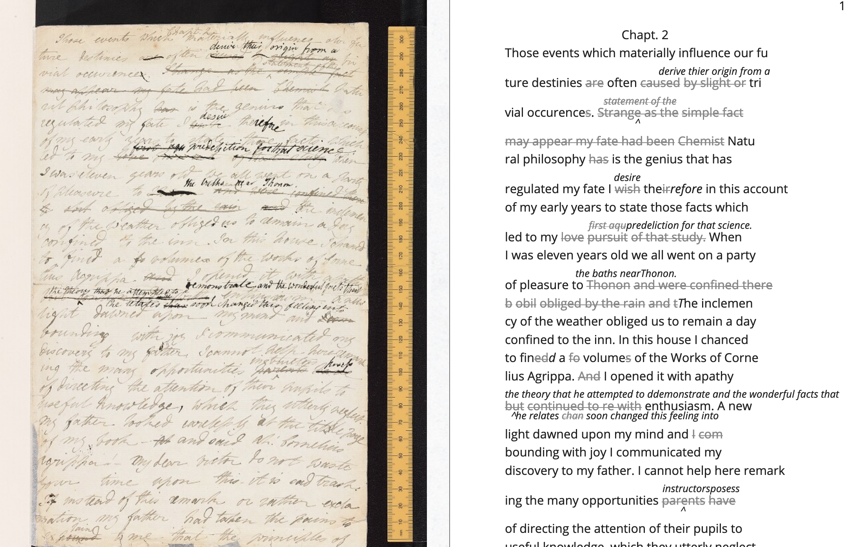

Figure 3: Image of the manuscript and diplomatic transcription of Frankenstein (Bodleian MS Abinger c.56: 1816), transcribed and encoded by the Shelley-Godwin Archive.

<handShift medium="pen" new="#mws"/>

<line>Those events which materially influence our fu</line>

<line>ture destinies <del rend="strikethrough">are</del> often <mod> <del rend="strikethrough">caused</del>

<del rend="strikethrough">by slight or</del>

<add hand="#pbs" place=”superlinear”>derive thier origin from a</add> </mod> tri </line>

<line>vial occurence <del rend="strikethrough">s</del>.

<mod spanTo="#c56-0005.01"/> <del rend="strikethrough" next="#c56-0005.02">Strange as the</del>

In the encoding, the <line> tags indicate lines of text, and <del> tags indicate deleted text. This excerpt also includes a <handShift> tag and @hand attribute, which indicate whose "hand" is responsible for writing each section of text: a valuable piece of information for a text co-edited by Shelley's husband, Percy Shelley. Through this level of detail, TEI facilitates deep and complex description of textual material for scholarly research.

TEI documents consist of an ordered hierarchy. The document organization resembles a tree structure, with one "root" element and several "branches." The TEI requires that all data be contained as discrete components within this bounded structure, and they cannot overlap unless the inner element is fully nested within an outer element. For example, a <del> element must be fully contained within its parent element, such as the <line> element.

Implied by this data model is a structure of dominance where the higher or "parent" element exerts control over the lower or "child" element. Within a hierarchical data model, conflicts arise when elements overlap. Element overlap is essential for some forms of written language where textual structure, such as syntax or grammar, might overlap with semantics. XML researcher Jeni Tennison points out that, "the way in which the syntactic (sentence/phrase) structure overlaps with the prosodic (stan/za/line) structure is one important way in which you can analyse a poem ("Overlap, Containment, and Dominance"). Tennison, who "want[s] to see if we can get away with not having hierarchy as a fundamental part of the information model," distinguishes dominance from containment:

When you’re talking about overlapping structures, it's useful to make the distinction between structures that contain each other and structures that dominate each other. Containment is a happenstance relationship between ranges while dominance is one that has a meaningful semantic. A page may happen to contain a stanza, but a poem dominates the stanzas that it contains. Tennison 2008, "Overlap, Containment, and Dominance"; emphasis original

To prioritize containment while also suggesting dominance relationships, Tennison proposes a new (but now unsupported) markup language: "The Layered Markup and Annotation Language" (LMNL). It uses a series of ranges that describe start and stop points for an element, rather than nesting elements one inside the other. In the example below, the tags are left open to accommodate additional ranges:

[book [title [lang}en{lang]}Genesis{title]}

[chapter}

[section [title}The creation of the world.{title]}

[para}

[v}[s}[note}In the beginning of creation, when God made heaven and earth,{note [alt}In the beginning God created heaven and earth.{alt]]{v] [v}the earth was without form and void, with darkness over the face of the abyss, [note}and a mighty wind that swept{note [alt}and the spirit of God hovering{alt]] over the surface of the waters.{s]{v] [v}[s}God said, [quote}[s}Let there be a light{s]{quote], and there was light;{v] [v}and God saw that the light was good, and he separated the light from darkness.{s]{v] [v}[s}He called the light day, and the darkness night. So evening came, and morning came, the first day.{s]{v]

{para] "The Layered Markup and Annotation Language (LMNL)"

This language indicates dominance relationships through layering markers, where one tag can overlap with another without being closed, rather than through a tree structure, where all elements must be nested. Due to this flattening of the hierarchy, however, the document object model is considerably less readable than the TEI.

The problem with TEI, and more deeply, with its parent structure, XML, is that dominance structures are totalizing. Attempts to curtail this dominance, as LMNL demonstrates, can result in redundancy and convolution. The TEI Guideline’s suggestions for handling dominance appear similarly complicated. Module 16, on "Linking, Segmentation, and Alignment," for example, describes various methods for encoding information that is not hierarchic or linear, including the use of pointers, segments, anchors, aggregation, and marginalization, among others. In Module 20, “Non-hierarchical Structures,” more suggestions include: “redundant encoding of information in multiple forms," and "the use of empty elements to delimit the boundaries of a non-nesting structure.” These solutions work by severing elements into components that maintain their own internal hierarchies which can be later recombined into the dominant hierarchy. When the totalizing nature of the TEI is diluted, the effect is to create a bureaucratization that disrupts its sense of unity.

Though the strict tagging structure of the TEI forces encoders to organize textual elements as discrete, ordered data, it also enables them to create their own labels for the elements. Perhaps the most useful aspect about the TEI is this customizability, which it inherits from its parent language, eXtensible Markup Language (XML). As an "extensible" language, TEI users can create their own tags to describe the particular elements they wish to encode. The Women Writers Project (WWP), directed by Julia Flanders, adequately frames how TEI's inherent extensibility can address textual ambiguity. According to the WWP:

Unlike many standardization efforts, the TEI … explicitly accommodat[es] variation and debate within its technical framework. The TEI Guidelines are designed to be both modular and customizable, so that specific projects can choose the relevant portions of the TEI and ignore the rest, and can also if necessary create extensions of the TEI language to describe facets of the text which the TEI does not yet address. Flanders, *WWP*

Because TEI is built from a language that allows its users to build their own version of that language, there is potential for representing the elements necessary for a project by customizing these elements on a project-by-project basis.

There are a number of projects that explore the potential of the TEI's customization to be used for "queer encoding," such as the encoding of queer gender. Marion Thain encodes the diaries of a complex writing subject: the late 19th-century English poet, Michael Field. Michael Field is a pen name for the lesbian couple, Katharine Bradley and Edith Cooper, which signifies "the assumed names of two separate women, as well as appearing to signify one single male identity" (Thain 228). Fortunately for Thain, the TEI enables the encoding of distinct identities, which is central for understanding the queerness of the diaries:

[T]he proliferation and slipperiness of names is no mere childish caprice but a core part of the articulation of queer: an unhinging of "given" or apparently predetermined identity through a strategy that articulates identity as constantly shifting, constructed, and performative. Text encoding can, in a simple but powerful way, help us explore and map this crucial strand of queer identity construction across the diary. 233

Thain's approach harnesses the hierarchical nature of the TEI to list the various references to each personage within the <persName> tag. This <persName> tag allows Thain to "render searchable words not in the text but intimately tied to it. This is not a small issue in a diary in which Katharine Bradley herself is referred to by more than 20 different names" (Thain 233). The TEI data structure enables Thain to encode multiple names for each writer in the text.

While some gender identities take multiple forms, some of which can be contained within a capacious enough set of tags and attributes, other gender identities may not fit into distinct categories. As gender and queer studies scholars may know, some identities will always a label. In this case, the problem goes deeper than the name of the tag itself and runs up against the hierarchical structure of the TEI document model. At the most recent annual TEI Conference and Members Meeting in 2022, Elisa Beshero-Bondar and her team reflect on their work developing a <gender> element for the TEI guidelines. Their project proposes a new <gender> element that is careful to weigh the expressive potential for representing gender against the possible risks of reifying normative cultural biases. Beshero-Bondar and her colleagues explain that,

Unexpectedly, we found ourselves confronting the Guidelines’ prioritization of personhood in discussion of sex, likely stemming from the conflation of sex and gender in the current version of the Guidelines. In revising the technical specifications describing sex, we introduced the term “organism” to broaden the application of sex encoding. We leave it to our community to investigate the fluid concepts of gender and sex in their textual manifestations of personhood and biological life. Beshero-Bondar et al.

While their new proposed element, <gender>, gives the team some capacity to represent gender as distinct from sex, the tagging structure nonetheless perpetuates a rule that "sex" serves some concept of personhood. The proposed solutions to this problem, which include exchanging <person> for the more capacious <organism> and <entity>, as recently proposed in the TEI documentation itself, keeps intact the notion that "sex" is something a person contains, that is, sex as something belonging to or expressed by a notion of personhood (martindholmes 2022).

It is safe to say that the TEI works effectively depending on the kind of queerness that we want to encode. If that queerness cannot be traced to a unified subjectivity or single gender, then encoding will be challenging. For example, tags such as <gender> or <person> limit elements to one value and creates obstacles for scholars working to encode multiple or diverse sexual identities. Here, Pamela Caughie and Sabine Meyer use the TEI to encode Man Into Woman, the life narrative of Danish painter Lili Elbe, who undertook one of the first gender affirming surgeries in 1930. The attempt to mark up Elbe's complex gender ontology brings Caughie and Meyer against this structural limitation of the TEI:

[T]he deeper we got into mark-up, the more evident it became that the categories and hierarchies available to us were inadequate for our task… to identify a male subject who at times presents himself as masquerading as a woman, at others as being inhabited by one, and who eventually becomes a woman, in a life history narrated retrospectively from the perspective of Lili Elbe. 231

The limitations of the <gender> tag forces these scholars to consider the ways that the TEI effectively reifies gender as essential. For this project, the fixity that the TEI imposes upon Elbe as a queer subject brings out the ways that gender is situated and relational across this text.

Why do Caughie and Meyer struggle to encode Elbe's identity while Thain appears to succeed with Fields'? This question about the TEI's capacity to adequately categorize queer identity points to a deeper problem within hierarchical data structures. While a queerness like Fields' might be delineated and contained, in Elbe's there is a quality of blending which the markup, by its nature, means to separate and fix. Fields' identity is multiple yet distinct: the diaries proffer "two different hands [that] record the experience of two clearly differentiated people" (Thain 229). By contrast, Elbe's identity is plural, containing several identities whose relationship to each other is ambiguous or continually shifting within one entity. Elbe's relation to gender is best described qualitatively, as one that alternatively "masquerades" or "inhabits" simultaneous gender ontologies (Caughie and Meyer 231).

## **The Manuscript of Dorian Gray**

For Wilde's text, I created a TEI customization that explores the potential of semantic labelling against the demands for fixity and structure within the TEI data structure. My customization registers physical and conceptual changes to the manuscript by creating two custom attributes to mark the revisions. First, the custom attribute @implication marks the general theme of revision from a list of recurring themes, which include: "intimacy," "beauty," "passion," and "fatality," with the additional values of "inconclusive," "unclear" or "illegible." Then, to mark the physical traces of Wilde's pen as he struck out portions of the text, I created the custom attribute @strokes that registers the number of pen strokes through any given section of text.[22] Most often, Wilde uses one or two strokes of his pen, although sometimes, the strokes are too heavy or thick to enumerate. In those cases, I set the @strokes attribute to the value "inconclusive." Below is an example of how the markup applies to a section of Wilde's manuscript. Here, I use default elements and attributes to mark the revisions, such as <mod>, <add>, <del>, as well as the built-in @rend, and @place attributes, to which I add my custom attributes, @implication and @strokes.

<quote> The ugly and the stupid have the best of it in this world. They can sit quietly, and gape at the play. If they know nothing of victory, they are

<mod type="subst">

<del rend="strikethrough"> <unclear>saved</unclear> </del>

<add>at least spared</add> </mod>

the knowledge of defeat. They live as we all should live, undisturbed, indifferent, and without disquiet. They neither bring ruin upon others, nor ever receive it from alien hands. Your rank and wealth, Harry; my brains, such as they are, my fame, whatever it may be worth; Dorian Grey's

<mod type="subst"> <del rend="strikethrough" strokes="2" implication="beauty">beauty;</del>

<add place="above">good looks;</add> </mod>

we will all suffer for what the Gods have given us, suffer terribly." </quote>

In what follows, I detail how this customization registers the elisions of homoeroticism in the manuscript as Wilde prepared it for publication. Here, the difficulty is in engaging the boundedness of the TEI elements, which encapsulate data, with the indistinctiveness of the queerness of the text, which resist demarcation. The four themes of "intimacy," "beauty," "passion," and "fatality" constitute a spectrum of smooth information that threatens the confines of the TEI tags. To add another layer of ambiguity, the number of pen strokes also resists easy demarcation: they can be difficult to enumerate, and their boundaries often fail to map with the themes. The goal of this work is not to establish a formal method for marking queer elements, rather, it is to surface a resistance in the text: an indeterminacy that resists capture by the TEI data structure.

The evocative opening scene, which consists of a lively dialogue between Basil Hallward and Lord Henry Wotton, sets the tone, reveals character dynamics, and lays out some of the conflict for the ensuing story. In these first few pages, Basil appears to be a sympathetic, sensitive, albeit slightly exasperated artist, who confides in his close friend Lord Henry the powerful influence that Dorian Gray has had upon his life and work. Lord Henry, by contrast, appears as an affable and witty gentleman aesthete, who counters Basil's sincerity with offbeat observations and paradoxical aphorisms. From the revisions that Wilde made to this opening scene, a few general patterns emerge. First, the revisions work to stifle the emotional tension and physical affection in the dialogue between Basil and Lord Henry, replacing it with a lighter or more neutral tone. Because such revisions generally shore up the friendship between Basil and Lord Henry, conveying fondness in their rapport, they are encoded according to the theme of "intimacy." Second, the themes of "beauty" and "passion" mostly concern revisions where Dorian is reformulated from a romantic object into an artistic subject for Basil's painting. Third, and finally, is the theme of "fatality," which emerges in moments where Basil struggles to explain the consuming and self-destructive effects of Dorian's influence on his life.

On the theme of intimacy, Wilde's pen slashes through evidence of physical contact between Basil, Lord Henry, and Dorian. This includes the following: "taking hold of his [Lord Henry's] hand" (9), Dorian's "cheek just brushed my [Basil's] cheek" (20), Basil and Dorian "sit beside each other" (22). Additionally, the dialogue between Basil and Lord Henry develops intimacy through their tone and subtle mannerisms, which facilitates Basil's confession of his feelings for Dorian. In some cases, Wilde diminishes this intimacy in their conversation with the effect of mitigating the sense of foreboding that surrounds Basil's attraction to Dorian. Here, Wilde replaces tense pauses with laughter or exchanges dramatic statements and descriptions with more playful ones. One such example occurs when Basil struggles to convey his reasoning for refusing to exhibit Dorian's portrait:

"The reason why I will not exhibit this picture, is that I am afraid that I have shown in it the secret of my own soul."

Lord Henry hesitated for a moment. "And what is that?" he asked, in a low voice. "I will tell you," said Hallward, and a look of pain came over his face. "Don't if you would rather not, murmured his companion, looking at him. (9)

The revised version in the manuscript, incorporating the deletions and interlinear additions, reads:

"The reason why I will not exhibit this picture, is that I am afraid that I have shown in it the secret of my own soul."

Lord Henry laughed. "And what is that?" he asked. "I will tell you," said Hallward, and an expression of perplexity came over his face. "I am all expectation Basil," murmured his companion, looking at him. (9)

Here, several changes mitigate the emotions of the scene. First, rather than "hesitate," Lord Henry "laugh[s]," and he no longer speaks "in a low voice." The effect is to overwrite a previously intimate moment with levity. Basil also exchanges his facial expression from one of agony to confusion when "a look of pain" transforms into "an expression of perplexity." Finally, Lord Henry, rather than sympathizing with Basil or excusing his obligation to explain himself, instead encourages him to speak: "I am all expectation, Basil." Together, these changes work to obscure Basil's internal suffering with the effect of lightening the mood of the scene.

Another example similarly tempers the intense, emotional energy while also mitigating a sense of anxiety or foreboding. It occurs on the following page, where Basil is on the verge of revealing the reasons behind his attraction to Dorian. The original dialogue proceeds: "Lord Henry felt as if he could hear Basil Hallward's heart beating, and he heard his own breath, with a sense almost of fear. 'Yes. There is very little to tell you,' whispered Hallward, 'and I am afraid you will be disappointed. Two months ago…'" (10). The manuscript's revised version reads: "Lord Henry felt as if he could hear Basil Hallward's heart beating, and he wondered what was coming. 'Yes. There is very little to tell you,' whispered Hallward rather bitterly, 'and I dare say you will be disappointed. Two months ago…'" (10). Here, rather than draw attention to Lord Henry's breathing, Wilde mentions Lord Henry's "wonder" about Basil's pending explanation, which shifts Lord Henry's sense of anticipation from fear to curiosity. Wilde also makes slight changes to Basil's delivery: in the revised version, Basil speaks "rather bitterly" and uses the expression "I dare say" rather than "I am afraid." Both changes diminish the confessional tone that originally precedes Basil's revelation about Dorian Gray. This intimacy between Basil and Lord Henry enables Basil's confession about the self-consuming qualities of his feelings for Dorian, which suggests a connection to the theme of fatality. The data structure of the TEI, however, fails to capture this complicated dynamic because the @implication attribute is limited to one value. Therefore, the encoder must choose one theme per item of revision, either @intimacy or @fatality.

Throughout this chapter, Wilde often swaps out words with the effect of diverting their original connotation to passion or romance. He focuses this type of revision on Basil's dialogue, when Basil speaks about his passionate attachment to Dorian and the effect of Dorian's beauty upon his art. Here, Wilde trades expressive nouns with words that convey more generalized ideas. For example, in the sentence "Every portrait that is painted with passion is a portrait of the artist, not of the sitter," Wilde replaces "passion" with "feeling" in the manuscript (9), exchanging the romantic connotation of "passion" with the more neutral one of "feeling." Additionally, on the theme of "passion," Wilde substitutes words and phrases which connote a strong sense of romantic passion for ones that instead suggest an aesthetic interest. One line, prior to revision, reads: "I knew that I had … come across someone whose mere personality was so fascinating that it would be Lord over my life, my soul, my art itself" (11). Wilde revises this line to: "I knew that I had come face to face with someone whose mere personality was so fascinating that it would absorb my nature, my soul, my art itself" (11). Here, Wilde swaps out "life" for "nature," with the effect of subscribing Dorian's influence to his "nature," that is, part of his personality or behavior, rather than encompassing his "life." Wilde also replaces "be Lord over" with "absorb," which maintains Basil's sense of submission to an external force without the patriarchal designation in "Lord." These changes, which are encoded under the theme of passion, diffuse a consuming quality in Basil's attraction into a sensitivity to Dorian's aesthetic influence. Like the revisions to the theme of intimacy, the subtle shifts in word choice in this section also begin to gesture to the theme of fatality, which fully develops over the next several pages.

In addition to words associated with passion, Wilde often replaces the word "beauty" in Basil's references to Dorian. In doing so, Wilde neutralizes the power of Dorian's physical allure. For example, Wilde changes "Suddenly I found myself face to face with the young man whose beauty had so stirred me" to "Suddenly I found myself face to face with the young man whose personality had so strangely stirred me" (13). The replacement of "beauty" with "personality" allows Basil to avoid mentioning Dorian's physical appearance, and the addition of "strangely" serves to mystify Dorian's influence over Basil. Throughout the rest of chapter, Wilde makes several changes that similarly dilute Dorian's powerful appearance: he replaces "beauty" with "good looks" and then with "face" two separate times (6, 18). Finally, in reference to Dorian Gray, the word "Narcissus" is replaced with "man" (13). Like the previous changes on the theme of passion, the changes in words associated with beauty shift the original connotation. Here, the decision to replace "beauty" with references to "face" or "good looks" maintains the emphasis on the physical while muting the suggestive power of "beauty" in the abstract. In doing so, connotations about the ideal, the charming, and the alluring, which usually accompany descriptions of beauty, are diffused into physical description. This evacuates Dorian's mysterious allure and diminishes the overwhelming influence that he holds over Basil.

Removing associations with beauty and passion is part of Wilde's larger effort of aestheticizing Dorian, transforming him from an erotic object into an aesthetic object. At the end of the first chapter, Basil implores Lord Henry to refrain from influencing the impressionable youth. The original version reads:

"Don't take away from me the one person that makes life lovely for me. Mind, Harry, I trust you." He spoke very slowly, and the words seemed wrung out of him, almost against his will.

"I don't suppose I shall care for him, and I am quite sure he won't care for me," replied Lord Henry smiling, and he took Hallward by the arm, and almost led him into the house. 27-28

Lord Henry's assurance that neither he nor Dorian shall "care for" each other characterizes Basil's passionate feelings for Dorian as a kind of general possessiveness. However, the source of Basil's anxiety is specified with the next revision:

"Don't take away from me the one person that makes life absolutely lovely to me, and that gives my art whatever wonder or charm it possesses. Mind. Harry, I trust you." He spoke very slowly, and the words seemed wrung out of him almost against his will.

"What nonsense you talk," said Lord Henry smiling, and, taking Hallward by the arm, he almost led him to the house. (27, 27B)

In this revision, Basil attributes an aesthetic value to Dorian, asserting Dorian's importance for his art, giving it "whatever wonder or charm it possesses." Lord Henry's response moves from reassurance to dismissal, rejecting Basil's anxiety as "nonsense" and ending the scene on a slightly humorous note. Across these changes, Wilde refocuses Basil's jealous passion into an anxiety about losing Dorian as an artistic subject. Additionally, the shift from sincere reassurance to light-hearted repartee in Lord Henry's response evacuates the strong emotional tone of the scene, replacing it with friendly banter. The effect is to divert Basil's passion for Dorian toward aesthetic appreciation.

Wilde's efforts in redirecting Basil's passion toward artistic ends is inextricable from the attempts to soften Basil's intense and consuming devotion to Dorian, which emerges in references to Basil's troubled state of mind. One example occurs when Basil recounts his first time meeting Dorian: "I had a strange feeling that Fate had in store for me exquisite joys and exquisite sorrows. I knew that if I spoke to him, I would never leave him till either he or I were dead. I grew afraid, and turned to quit the room" (12). Here, Basil's passion swells with an intense, life-threatening quality that Wilde's pen works to mitigate by removing the association with death. He crosses through "never leave him till either he or I were dead" and adds "become absolutely devoted to him, and that I ought not to speak to him." Wilde again tempers this self-consuming quality of Basil's devotion when he changes the phrase "I could not live if I did not see him every day" to "I couldn't be happy if I didn't see him every day" (17). By shifting the focus from Basil's "life" to his happiness, Wilde dilutes the profound peril that Basil's passion has generated.

The TEI data structure reinforces the difficulty of disambiguating the revisions within the themes of passion and fatality. In the phrase discussed above, "look of pain" is revised to "an expression of perplexity" (see Figures 4 and 5). Working with this revision in the TEI presents two points of contention. First, in categorizing the theme, does the phrase "look of pain" express passion or fatality? On the one hand, "pain" denotes a strong, passionate feeling; on the other, Basil often draws on pain in his references to the fatalistic qualities about his attraction to Dorian, as in the following quote which was deleted: "I feel, Harry, that I have given away my whole soul to someone seems to take a real delight in giving me pain" (23). The difficulty of disambiguating the theme is mirrored by the strokes of Wilde's pen, which vary even across the same phrase: while the word "look" is struck so heavily that the number of strokes is inconclusive, the word "pain" contains a single stroke. With the TEI, it is impossible to mark the variations in strokes without separating the single revision into two instances, which would break up the integrity of the phrase. Therefore, it is marked with the value "inconclusive." The ambiguity in the number of strokes also deepens when considering the semantics of the revision: the heavier strokes are focused on a revision ("look" to "expression") that carries less semantic weight than the single stroke ("pain" to "perplexity"). In this case, the labelling fails to register the ways that different components are interrelated. Any congruence between the themes and the strokes remains unresolved.

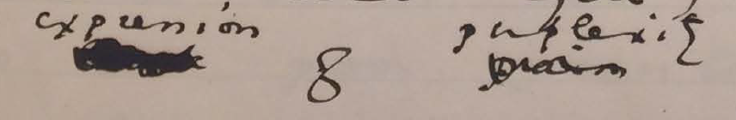Figure 4: Close-up image of detail on MS 9 from The Morgan Library and Museum.

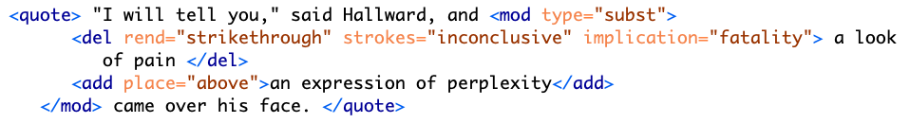Figure 5: Text encoding for page MS 9 detail.

My final example concerns a longer passage that was heavily revised in the manuscript (see Figures 6 and 7). The treatment of this passage crystallizes the various patterns of revision seen so far—diminishing signs of intimacy, passion, and references to Basil's fatalism. The passage in the manuscript bears quoting in full. Prior to any revisions, it reads:

"You remember that landscape of mine… It is one of the best things I have ever done. And why is it so? Because, while I was painting it, Dorian Gray sat beside me, and as he leaned across to look at it, his cheek just brushed my cheek. The world becomes young to me when I hold his hand, as when I see him, the centuries yield up all their secrets!"

"Basil, this is [illegible] you must not talk [illegible] [illegible] his power, [indecipherable] to make yourself the [illegible] slave! It is worse than wicked, it is silly. I hate Dorian Gray."

Hallward got up from the seat, and walked up and down the garden. A curious smile curled his lips. He seemed like a man in a dream. After some time he came back. "You don't understand, Harry…" he said. "Dorian Gray is merely to me a motive in art. He is never more present in my work then when no image of him is there. He is simply a suggestion, as I have said, of a new manner. I see him in the curves of certain lines, in the loveliness and subtleties of certain colours. That is all."

"Then why won't you exhibit his picture?"

"Because I have put into it the romance of which I have never dared to speak to him. He knows nothing about it, but the world might guess it, where there is merely love, they would see something evil, where there is spectacular passion, they would suggest something vile." (20-21)

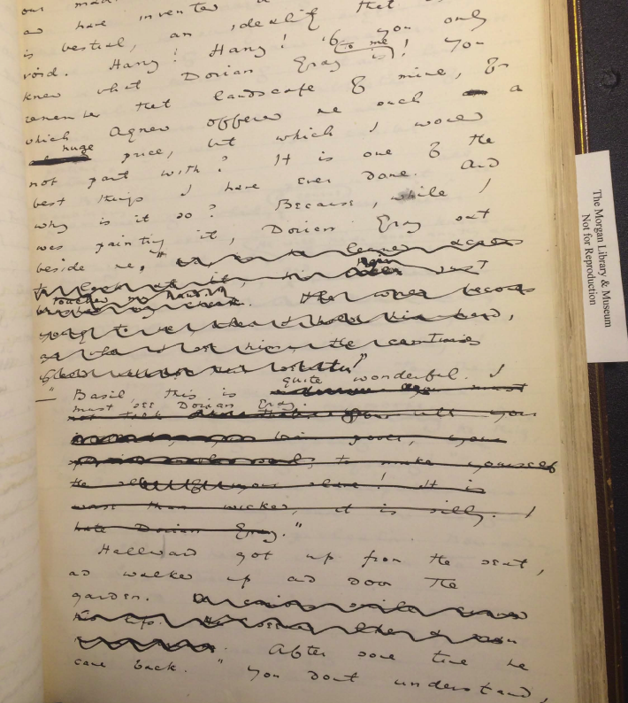Figure 6: MS page 20 from The Morgan Library and Museum.

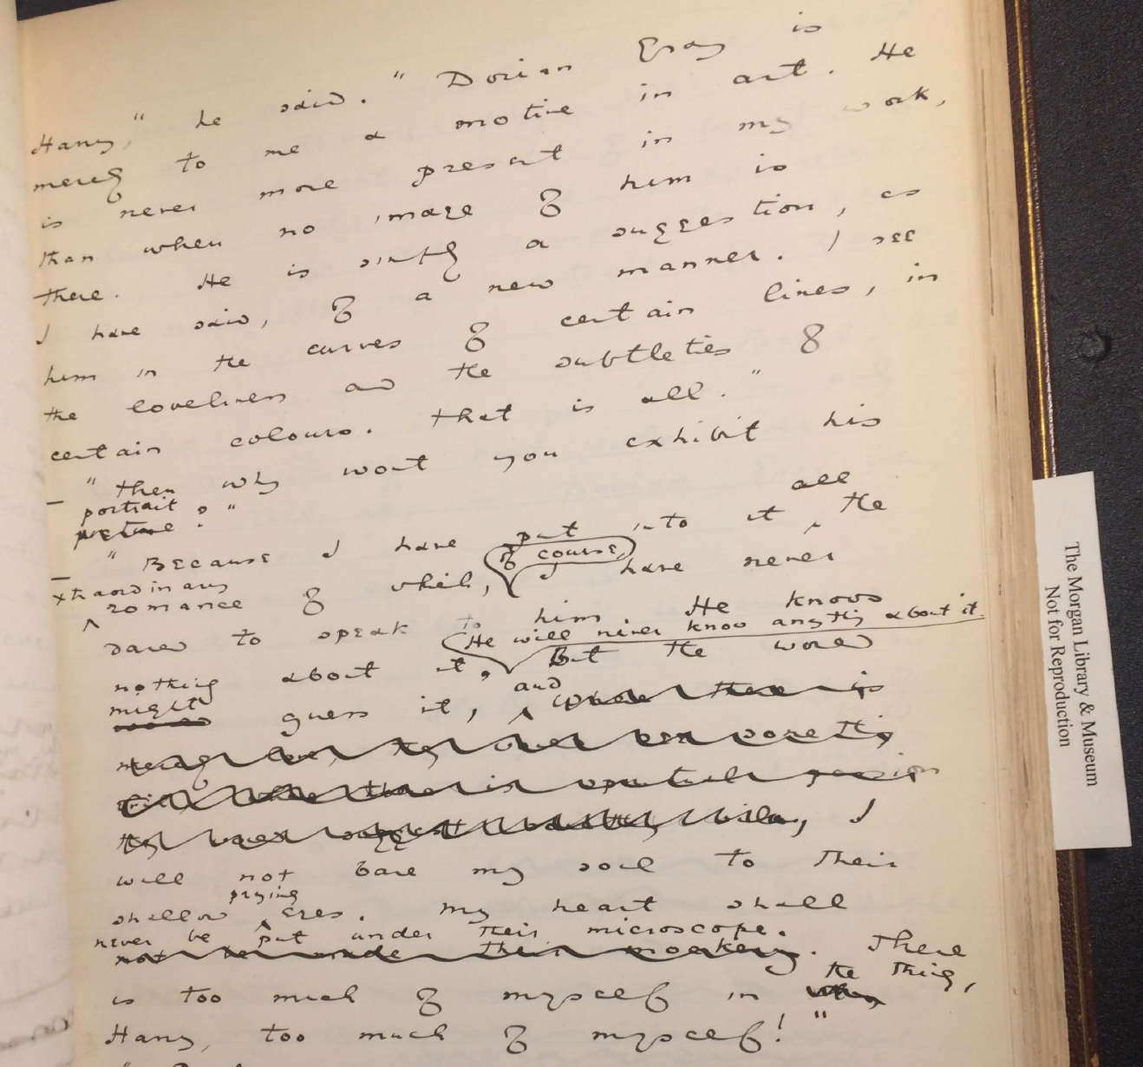Figure 7: MS page 21 from The Morgan Library and Museum.

The TEI surfaces Wilde's layers of revision in this passage (see Figures 8 and 9). In the first paragraph, Wilde eliminates a span of text from "and as he leaned" to "secrets!". Within this span, Wilde makes additional changes, adding text such as "hair just touched my hand," which replaces "cheek just brushed my cheek." Due to its physical nature, this particular phrase is marked as "intimacy" in the TEI, while the longer section is enclosed by the label of "passion," which denotes the nature of the other revisions within the same sentence, like "The world becomes young to me when I hold his hand." Here, the TEI enables a layered approach to markup where one element can be nested within another.

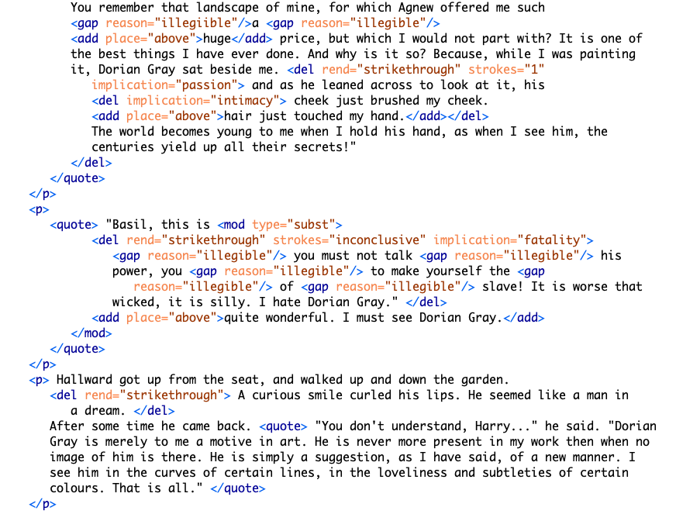Figure 8: Text encoding for MS pages 20–21.

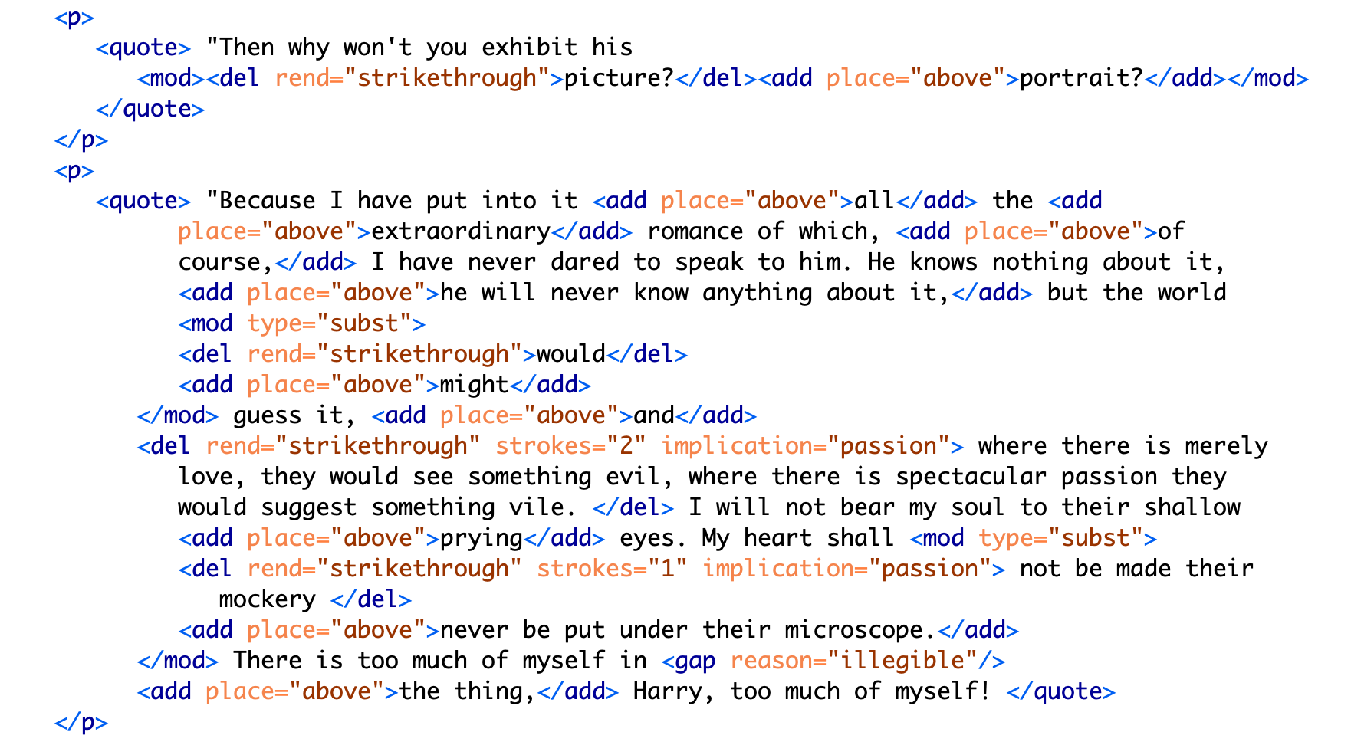Figure 9: Text encoding for MS pages 20-21 continued.

While the first paragraph is legible, the next one, by contrast, is almost completely blotted out. It consists of Lord Henry's condemnatory and jealous protestations: "his power," "to make yourself the … slave!" and "I hate Dorian Gray." Here, Wilde obscures the fatalistic connotations of Basil's passion, which exasperate Lord Henry. Accordingly, the @implication is marked as "fatality" and the @strokes are marked as "inconclusive."

Most of the third paragraph is preserved, presumably for how it furthers Dorian's aestheticization as a muse for Basil's painting. The following paragraph, however, obscures much of language, which revolves around the themes of passion and fatality. On the theme of fatality, the small adjustment of "would" to "might" eliminates a sense of inevitability about Basil's feelings for Dorian. On the theme of passion, the revelatory line: "where there is merely love, they would see something evil, where there is spectacular passion, they would suggest something vile" is completely struck out. This statement clarifies Dorian's importance for Basil as the source of a powerful allure that suffuses Basil's art with beauty. Notably, the strokes over the phrase "suggest something vile" are doubled, which cannot be encoded in the TEI without separating the revision into two instances. As with the deletion of "look of pain" (9), marking each element here with precision would require separating into distinct entities what is in fact one act of revision that contains plural implications. It would involve resolving Wilde's perhaps indeterminate motives into a single intention.

On one level, the TEI encoding reinforces the claim by Lawlor, Frankel, and Bristow that Wilde diminishes the homoerotic elements by transforming Dorian from an erotic into an aesthetic object. This goal is achieved in three ways: first, by easing the tension surrounding his dialogue with Lord Henry; second, by emphasizing Dorian as an ideal subject for art; and finally, by removing the destructive connotations of Basil's attachment to Dorian. On a deeper level, however, the existing textual scholarship has yet to contend with the complex ways in which Wilde's intentionality is distributed among the revisions. To resolve some of the difficulty with encoding this text, one might employ more precise qualitative markers such as "tension" in addition to "intimacy," or "ardor" and "devotion," in addition to "passion," for example. At the same time, however, creating more tags would dilute the analytical utility of the TEI encoding, which is meant not meant to be exhaustive.

In this project, the TEI reveals that the themes of intimacy, beauty, passion, and fatality operate in intransigent or inscrutable ways: They may be plural, co-existing within a single line of text; they may be inextricable, with one enabling the other, like intimacy and passion which enable fatality; or they might enfold one within the other, encompassing a plurality of intentions. The TEI, which requires strict disambiguation, surfaces how these themes work together in ways that cannot be captured by its data structure.

## **Conclusion**

The more that I work with the TEI, the more I come to realize that the problem with its data model goes beyond the boundedness of its elements, and toward a dominating, top-down structure that it imposes on textual data. At the root of the TEI's rigidity is its hierarchical document model where each element within the tree structure subscribes to its parent element and dominates its subordinate ones. Within this tree-like architecture, information is not only encapsulated or bound, it is delineated by the standards of each governing tag, its syntax, model, attributes, and contents.

I find that underlying Ruddick's two "unspeakable" morals about beauty and homosexuality, there is a third level of "unspeakability"–about power, about who has it and who is subject to it. For this text in particular, the dominant force is that of the writer himself, a writer with nearly every privilege–gender, racial, financial, cultural, and educational–who censors his own writing. What about texts whose writers or subjects are subscribed to larger systems of domination, such historical forces of discrimination, exploitation, and oppression? To better understand the role of dominance in delimiting data forms, it is useful to turn to an archive that has been totally dominated by power structures. One such archive comprises Jessica Marie Johnson's subject matter in her book, Wicked Flesh: Black Women, Intimacy, and Freedom in the Atlantic World. Here Johnson studies the history of black women in the 17th and 18th century Atlantic world by reading through and between official documents and historiographical records written by slave-owning men, traders, and colonial officials. From these records, which "often contain incomplete information," Johnson weaves a history "in careful and creative ways" (Johnson 5). Her readings of these documents surface a complicated and nuanced picture of black womens' lives and how they negotiated their own freedom practices within white, male, slave-owning male dominated world.

Johnson illustrates two strategies for approaching this dataset: the first is a strategy of narration, where Johnson interweaves fragments that, on their own, tell a story of bondage and subjection to power. She begins by framing each chapter with the story of different figure from the archive, constructing for the reader a vivid scene from the woman's life in a way that foregrounds her character and accomplishment. The first chapter, for example, presents Seignora Catti, "a wealthy merchant in her own right, [who] had leveraged her status as the wife of a European against her commercial savvy and the opportunities and experience of living in the middle ground between the Atlantic Ocean to the west and the Wolof sovereigns in the east for her own benefit" (Johnson 16). The notes reveal that the sources for Catti's biography stem from biographical writings featuring Jean Barbot, a commercial agent for a French slaving company based in Senegal. In Johnson's narrative, Barbot's role is delimited to a supporting character, to a guest at Catti's dinner party whose presence serves to bring Catti into the foreground.

In addition to narrativizing between the gaps in the record, Johnson also magnifies and resignifies these gaps. Johnson finds novel ways of handling information that is absent from the archive, for example, a census that ignores the presence of black women and girls living in the New Orleans area in the early 18th century. Reading these absences as "null values,"[23] rather than absent or zero values, Johnson "resist[s] equating the missing or inapplicable information with black death" (135). Emphasizing these "null" values allows Johnson to index where these women exceed the logics of colonial subjectification:

It is possible to see their absence as evidence of either their perceived nonexistence or lack of importance, or inferior data-collection practices. It is also possible, however, to hear in the register's silence the ecstatic shout of black freedom practices transgressing colonial desires, black people forming maps of kin between towns and countryside, black women loving each other into free states that could not be counted by census officials, much less managed by imperial entities or recorded on manuscript pages. 143

By making a space for silence, Johnson can reframe the effects of absence within the archive. Johnson demonstrates where these women, who were not counted, "exceed the bounds of colonial power" that is based on the quantification and commodification of black life, rather than reify the dominating narrative of black subjugation or death. The histories of what could have been, which do not fit into dominant systems of colonial quantification, include the radical seeking of “joy and pleasure, g[iving] birth, mother[ing] spaces of care and celebration, and cultivat[ing] expressive and embodied aesthetic practices to heal from the everyday toil of their laboring lives” (Johnson 10). These null values allow Johnson to frame "blackness not as bondage… but as future possibility" (Johnson 2020, 10).

Johnson's historiographical project requires more than just assembling fragments that survive or resignifying the silences in their place; it requires narrating from what Johnson describes as "a deeper well of women, communities, practices, strategies, failures, and terrors that shaped the meaning of freedom and a faith in the possibility of emancipation" (Johnson 231). Johnson explains,

It is from these depths, deeper than exceptional names and silent registers, that black women remember their mothers, daughters, godmothers, and aunts. Black communities remember each other, in family whispers, at altars, and at communion. Historians, bound by archives, may scrape dusty folios for sources, may question whether women and girls will appear or worry that when they do appear, they emerge as legends, myths, and motifs representing more than themselves. That is not the intellectual tradition this book was written in. 231

This distinction between record and memory is the key to Johnson's historiographical method. Memory is a space that, by design, cannot be recorded or "marked up." Memory, which is maintained by community and fuelled by imagination, is a space that cannot be regulated and delimited like documents.

How might this historiographical approach for resisting dominance structures apply to editorial work? Within an extremely delineated set of records, which contain only minimal data about the lives she intends to surface, Johnson works to read through and between the gaps in the record. The TEI might also work with and through gaps, not of a data structure, but of a larger system of dominance that enables editorial work in the first place. As electronic editing scholar Amy Earhart emphasizes, editorial practices are bound by structures deeper than the TEI data format–institutional support and funding. In order to pursue a TEI project, researchers need time, money, training, and access. These obstacles preclude many text encoding projects from beginning in the first place and limit their ability to succeed. To highlight the influence of this structure on text encoding work, I will close by briefly looking at how two projects take what Earhart describes as a "DIY approach" that defies the structural constraints of both the institution and the data format (Earhart 2010, 314).

The first project, the Editing the Eartha M.M. White Collection, uses community-based strategies to encourage and train beginner encoders. Based at the University of Florida, this project contains an electronic archive of personal correspondence and other documents related to Eartha M.M. White (1876–1974), the founder of the Clara White Mission and a leader of Jacksonville, Florida's African American community. Beginning in a classroom in 2016, this project continues to grow through the collaborative effort of students, faculty, staff at UNF, with recent efforts being made to expand into the Jacksonville community more broadly. To facilitate collaboration on the project, they share their TEI documents on GitHub, an online space for publishing digital work (used primarily for collaborating on open software), and offer detailed, step-by-step instructions for new editors to get started with text encoding. The introductory guide to the archive, aimed at all levels of experience, indicates that this project draws significantly from a non-specialist and community knowledge.

The second project, The Peter Still Papers, strategically deploys a minimal approach toward text encoding. Based at Rutgers University, this project collects and publishes correspondence (1850-1875) relating to former slave Peter Still’s attempts to purchase freedom for his wife and children in Alabama, and includes letters by William Lloyd Garrison, Horace Greeley, and Harriet Beecher Stowe. This "Documentary Edition" makes selective use of tags based on the TEI-Lite model, with the goal of bringing out a particular narrative among the papers:

Our intention with the markup has been to produce a rough idea of the aboutness of each letter, and not to count every reference to a person or a place. Consequently, the persName and placeName tags have been used selectively…. in the personography file, we have made an attempt to include only those people who were significant in Peter Still’s world, namely family, friends, and people who helped or hindered him in his mission. The Peter Still Papers 2015-2022, "About"

Their minimalist tagging scheme reflects an inventive approach toward the structural limitations surrounding the creation of the archive: first, the scope of the documents themselves, none of which are written in Still’s hand, reflect what editors describe as "only one side of a conversation, punctuated by many gaps and omissions" (The Peter Still Papers 2015-2022, "About). Additionally, like the Editing the Eartha M.M. White Collection, this project draws from a range of skillsets, specifically from non-specialists in American history, as "no member of the project team is a historian by training, nor expert in the period in question" (The Peter Still Papers 2015-2022, “About”).

Both Editing the Eartha M.M. White Collection and The Peter Still Papers work within limited structures–-institutional and informational structures–-toward collaborative and community-oriented encoding approaches. They demonstrate that resistance is not just another formal experiment, where non-normative bodies challenge subscription into an oppressive mainstream. It is a political project that foregrounds that which cannot be incorporated into the mainstream.

The answer to Flanders's question, "do we need to queer markup, or is markup already queerable?" seems to be depend on the kind of structure that the encoder is challenging within the document (2017). For Wilde's project, the TEI enables an approach toward editing which surfaces how queerness slips through attempts at demarcation. By encouraging encoders to impose a level of fixity on the text, the TEI allows them to discover exactly where queerness eludes containment. One may examine the formalizations produced by this TEI schema not for what it reveals about Wilde's intentions, but for how it releases potential readings of the history of his composition, in other words, to mark and visualize its queer form: the elusive affects, repressed desires, and other coded elements of queerness within this text.

Self-revision, or even self-censorship, is not the same as being silenced. The TEI approach to editing tells a compelling story about Wilde's work in supressing or transforming the homoerotic elements in his story. But it does so within a vacuum of Wilde's own implicit privilege, particularly his agency in deciding what to change and how. Wilde's own power here operates as the dominating force, but one that is easily overlooked or taken for granted in the name of recovery. The data structure and format may encourage encoders, as it did this one, to ignore larger systems of domination operating around the text. If used thoughtfully and critically, however, the TEI might eventually surface that which escapes its own structure, in order to suggest, without resolving, the ever-shifting permutations of power.

1. As George Landow points out in his seminal work on hypertext theory, theories of textuality by post-structuralists like Roland Barthes and Jacques Derrida have a lot to offer in the interpretation of hypermedia. For example, Derrida's idea of "de-centering" and Barthes's idea of the "readerly" versus "writerly" texts. See Landow.
2. Butler draws from Michel Foucault's deconstruction of power and its operations through "discourse," demonstrating how what appears to be a repression of sexuality results in the codification of sexuality and its multiplication into various forms and discourses. See Foucault, Michel, and Robert Hurley.
3. For more on blackness and tracking technology, see Browne, Simone. For more on the relationship between blackness and media, see Nelson, Alondra.
4. Muñoz builds from Chicana theorists Norma Alarcón's idea of "differential consciousness" and Chela Sandoval's concept of emergent identities-in-difference, which center moments of failed interpellation as the core materials of subject formation, to a general paradigm of identity formation that he calls "identities-in-difference" (Disidentifications 6).
5. Text analysis borrows from Natural Language Processing and Machine Learning methods to do analyses like Topic Modeling, Sentiment Analysis, and Logistic Regression (discussed below). Though these methods differ in important ways, they share in basic tasks of counting and classifying words and other textual elements with the goal of predicting and visualizing patterns in text.
6. In the wake of the #metoo movement in 2017, three graduate students accused Moretti of harassment and assault. Stanford university claimed to be reviewing the case with no formal proceedings or other action being taken. See Liu, Fangzhou and Hannah Knowles.
7. For a more thorough critique of Da's aims and methodology in this article, please see Ben Schmidt's "A computational critique of a computational critique of computational critique,"
8. In his book *Reading Machines*, Ramsay draws from the deformative critical methods of Jerome McGann and Lisa Samuels to harness the enabling constraints of computation that "unleash the potentialities" of the text, offering opportunities for new readings (33).
9. In their introduction to *The Journal for Cultural Analytics*'s "Identity Issue," Brown and Mandell situate feminist debates around identity politics as a necessary context for understanding how computational processes engage gender identity.
10. In *Gender Trouble: Feminism and the Subversion of Identity* (1990), Judith Butler famously disrupts two essentialist views of sex and gender in contemporary feminist thought: first, that sex is biological while gender is constructed; and second, the gender, as a construction, is a self-expression of the subject. According to Butler, there is no such thing as a subject that exists prior to gender expression, as a subject only comes into being by participating in a gender norm.
11. Common critiques of Butler point out the limits of this theory for posing gender and sexuality as discursive. From the field of Trans Studies, Jay Prosser problematizes Butler's "deliteralization of sex," a critique that he applies to Queer Studies more generally. Prosser explains that because Butler's analysis attends to performativity as a discursive phenomenon, it elides the real-world concerns of the body's materiality. Prosser offers the example of Butler's reading of *Paris Is Burning*'s Venus Xtravaganza who, Butler argues, occupies a space of transgression due to her inability to attain her sex change. According to Butler, a sex change that would "make [her]self complete" would also fulfill the desire for a masculine body would reinscribe heterosexual hegemony (45). Prosser points out that this reading fails to reckon with the material body and its precarious existence, as Venus's death illustrates (55). Butler's "metaphorization of the transgender body" demonstrates one crucial way that Queer Theory has subsumed, without fully accounting for, transgressive desires in cross-gendered identifications.
12. Irigaray here critiques Jacques Derrida famously defines as "phallogocentrism," the idea that man, symbolized by the phallus, is the center and focus of knowledge.
13. Irigaray's concept of the "necessary outside" seems to anticipate another popular critique of Butler's theory, from the field of Political Philosophy, which claims a logical inconsistency in Butler's theorization of subjectivity. If the resistance to signification comes from outside the cycle of signification, does this not imply a pre-discursive identity or at least desire for resistance? Geoff Boucher writes that Butler locates the potential for subversion "in a disembodied intentionality that appears to stand outside of the culturally-scripted subject positions that the individual occupies" (115).
14. It almost goes without saying–the formula reproduces gender as a binary structure, where "Queen" is computed through its relation to "King" and "Man."
15. The language model for this computation comes from Word2Vec's "glove-twitter-25" dataset, which is based on Twitter data.
16. Jamie Hovey and Jessica Berman both explore how the text challenges the boundaries of national identity through an implicit critique of imperialism, a critique that emerges from the privileged position of the white, British perspective. Hovey remarks that *Orlando* is "an ambivalent articulation of English nationalism," a nationalism that intersects with (and depends on) gender and race (Hovey 394). Displacing the oppressive effects of nationalism to racialized and sexually transgressive subjects, the novel "allows the protagonist to pass as respectable and heterosexual" (Hovey 398). Bringing the question of transsexuality to the fore, Berman argue that as a "trans text," *Orlando* utilizes methods of marking and categorizing bodies to interrogate the structures and boundaries of nationality (Berman 218). According to Berman, "The transnational situation as also intrinsically transgender" (Berman 218). Berman's account harps on "the disruptive, critical energy of the prefix 'trans'" to unpack the concept of "nation" and "nationality" (Berman 220).
17. See this dissertation's introduction for a more detailed explanation of this tension in Queer DH.
18. See Frankel, pp. 40–54, for a more complete accounting of the role of John Marshall Stoddart (Wilde’s publisher) in preparing the typescript for publication.
19. See Wilde, O and M P Gillespie, pp. 358–374, for a selected list of full-length reviews from The Scots Observer, The St James Gazette and the Daily Chronicle, and Wilde's responses.
20. See Wilde, O and M P Gillespie, pp. 3–4.
21. As the condition of rescuing his lover Eurydice from Hades, Orpheus must not look at her until they exit the Underworld and re-emerge into the sunlight. Unable to restrain himself, Orpheus turns to gaze at Eurydice as they are about to pass through the threshold. In this glimpse he manages to catch of his lover, she is already shrinking away into the darkness where she will be forever imprisoned.
22. I am grateful to Jason A. Boyd for making this suggestion.
23. Johnson here draws from Jacob Gaboury's work on resisting compulsory identification in social media. See Gaboury, Jacob. "Becoming NULL: Queer Relations in the Excluded Middle." Women & Performance: a Journal of Feminist Theory. 28:2, 2018. pp. 143-158.